NAR Short Sale Issues Working Group

The Short Sale Workflow

This short sales work flow is an educational tool intended to give brokers and sales associates a comprehensive overview of the short sale process (listing, marketing, negotiating and closing properties subject to a potential short sale). It is not intended to and does not constitute legal, financial or tax advice, and should not be interpreted as policy of the national association. To the extent legal, financial or tax advice is needed by a member or a member’s client or customer, those individuals should be encouraged to consult with their lawyer or accountant.
State and local associations may supplement or modify the short sales work flow based upon laws and regulations affecting their jurisdiction. Individual brokers may also use the short sale work flow as the basis for their firms’ brokerage policies by modifying it, with the advice of counsel, to reflect not only state and local laws and regulations but also their firms’ policies and procedures. Realtors® and member boards are authorized to modify, reproduce and distribute the short sale work flow.
The contributions of REALTORS® serving on the NAR risk management, multiple listing issues and policies, professional standards, and conventional finance and lending committees to the development of this document and other educational and informational tools to assist realtors® dealing with short sales are gratefully appreciated.

The Short Sale Workflow

What the Listing Agent Should Know to Successfully Negotiate a Short Sale

What is a Short Sale?

The Work Group defined a “Short Sale” as follows:

A short sale is one where title has transferred; where the sales price was insufficient to pay the total of all liens and costs of sale; and where the seller did not bring sufficient liquid assets to the closing to cure all deficiencies.

What is a “Potential Short Sale”?

The Work Group defined a “Potential Short Sale” as follows:

A potential short sale is one where the listing agent reasonably believes the purchase price may not be enough to cover payment of all liens and costs of sale and the seller is unwilling or unable to bring sufficient liquid assets to the closing.

When first dealing with a potential short sale situation members are urged to consult with their broker, attorney and risk manager to determine the correct approach in their particular market area. The following is a suggested workflow for agents interested in representing sellers who are or who may be in a short sale situation. It is intended to educate members regarding issues that arise in connection with short sales. If modified by a broker as necessary to reflect local and state laws, requirements and procedures and the broker’s own office policies, which should be created with the advice of the broker’s counsel, it may also be used as a guide for agents operating within a broker’s office.

- Educate and Prepare Yourself

  - Ask your broker if your company has policies and procedures regarding short sales. Follow those guidelines to the extent they comport with federal, state, and local laws, MLS rules, the REALTOR® Code of Ethics, and your state’s real estate regulations.

  - Know the laws, procedures, and timelines regarding foreclosure in your state. These vary widely. Some states use court proceedings to effectuate foreclosures. These are called “judicial foreclosures”. Other states use less formal procedures, such as trustees sales, referred to generally as “non-judicial foreclosures”. Some states, such as California, utilize both. The most obvious difference is that non-judicial states have a much shorter timeline to foreclosure, but generally offer a right of redemption, while states utilizing judicial foreclosures usually take longer to complete the foreclosure process, but the former mortgagor did not generally have recourse after the sale. An informal survey of foreclosure timelines suggests that a foreclosure can take as little as 90 days, and as long as a year or more. It is critical that you understand the procedures and timelines in your state, even if the property you are dealing with is not yet in foreclosure.

  - Read the most up-to-date material on short sales from reputable sources such as the National Association of REALTORS® and your local and state REALTOR® associations. Be aware that there are a number of illegitimate, ineffective and illegal approaches to short sales that are being heavily promoted to sellers and real estate agents alike. Be mindful that your fiduciary responsibility to your seller applies in a short sale situation just as it applies in any other sale.

  - Research and read online articles and advice on short sales so you will be prepared for seller questions based on those materials. Sellers can become badly misinformed by relying solely on online short sale advice.

  - Seek out other reputable agents and brokers in your area who are doing short sales. What have they learned? What are their best practices? What are the pitfalls?

  - Speak with local attorneys and CPAs who are proficient in short sales.

- Gather Information from the Seller and Other Sources

  - It is important to be aware of how much is owed on the property and whether the seller is in default on any mortgage liens, taxes, or association dues. Ask the seller for copies of the most recent mortgage statement(s) including second mortgages and lines of credit. Ask for the most recent property tax statement and association dues bill. Check with the tax assessor, title company, and association, if necessary, to verify the total debt and any arrears and penalties. Know that the seller is not always aware of the total debt, and may minimize or misstate it if you simply rely on a verbal conversation.

  - Is the seller in default on any liens? If so, has any legal action been taken by the lienholder(s)? This is where it will be important to know what the local procedures and timelines are. If you see that action has been taken, inform the seller in writing. Sellers do not always know they are about to lose their homes.

  - Is the seller aware that there may be insufficient equity? This can be important because the seller may believe that the value of their home is higher than it actually is. It is especially important to be as accurate as possible in your market value assessment.

  - Create a careful Comparative Market Analysis (CMA) or Broker Price Opinion (BPO) using the most current comparable sales. Be realistic about the value. Short sellers cannot usually afford to try a high price first then adjust down over time. Include all costs of sale, such as commissions, closing costs, any interest and penalties on loans or taxes in default. In your best judgment, will there be positive proceeds or does the seller owe more than the property is currently worth after all selling costs?

  - Finally, find out whether the loan(s) that might be subject to a deficiency in a short sale are “Recourse” or Non-recourse”. In a recourse loan, the borrower retains personal liability for any deficiency after a sale or foreclosure. The lender has “recourse” to the personal assets of the borrower to make up any deficiency. In a non-recourse loan the lender is limited to whatever funds are available from its security interest in the property itself, and cannot force the borrower to repay any deficiency. Each state has its own rules and in some states a loan can be either recourse or non-recourse depending on factors such as whether it was a purchase money loan or a refinance. These are legal questions. Do not try to answer them yourself. Always recommend professional legal, credit, and tax advice.

- Meet with the Seller to Discuss and Evaluate the Options

  - Assume you have concluded the seller owes more than the property is now worth. It is important at this point that you advise the seller, in writing, to obtain separate legal, credit, and tax advice. The decisions the seller will be making all have legal, financial, tax, and credit implications. A short sale should never be the first choice because it carries with it serious negative credit and, possibly, tax consequences. Potential short sellers should always be advised that any action they take other than full payment of the mortgage note will have negative credit consequences. Sellers should be encouraged to consult with a HUD-approved credit counseling agency prior to making any decisions. Sellers should be cautioned that when selecting a credit counselor to carefully check the credentials of the agency as not every credit counselor or foreclosure rescue specialist is going to be HUD-approved. What are the options available to the seller? In rough order of “least damage to credit” to “most damage to credit” they are:

    - Keep the Property. If the seller is unhappy that the property value is less than the loan balance, but is otherwise under no pressure to sell, keeping the property can be the best solution. Even if there is some short term financial distress, it need not result in loss of the property. Ask if there are family or other resources that can carry the seller through if there is some financial stress. Because of the lack of equity, a refinance may not be possible, but be aware of any special “hardship refinance” programs a particular lender may offer, including the Making Home Affordable refinancing and loan modification programs of the Obama Administration. The various programs change frequently. If the sellers must move, could they rent the property (even at a negative cash flow) and sell it later in a better market?

    - Sell the Property and Bring Cash to Close Escrow. This might not sound appealing, but it can be a good choice for sellers who are in a financial position to pay a deficiency from other liquid assets. This approach avoids the credit damage that even a successful short sale will cause. An alternative in some circumstances is for the seller to agree to convert any deficiency into a personal note, or a note on another property owned by the seller. REALTORS® should always advise sellers to consult appropriate legal and tax professionals before considering such a note.

    - Attempt a Workout with the Lender. Lenders advise NAR that they must speak with the borrower directly about all options before it will consider approving a short sale. Lenders are increasingly interested in helping financially distressed homeowners stay in their homes, and are required to do so if participating in the Making Home Affordable programs. In some cases, they have been willing to reduce or roll back interest rates, or reduce the allowable payment, to help sellers avoid short sales and foreclosures. It is not generally advisable for the agent to take the lead in representing a property owner in a workout. Workouts are not real estate transactions. They are complex contract modifications, and to date, relatively few homeowners in distress have been able to come to a permanent agreement with their lender. The homeowner should be advised to consult an attorney if this is the option they choose. Note that new laws and emerging policies and procedures by the Obama Administration, Fannie Mae, Freddie Mac, the VA, the FHA, and private lenders make the workout option more complex, but also present greater opportunities for financially distressed homeowners.

    - Offer the Lender a “Deed in Lieu of Foreclosure”. If the seller owes more money than the property is worth, is unable to make payments, and is likely to lose the property in foreclosure in the near future, offering to trade the property to the lender in exchange for the cancellation of the note might make sense. This approach is more likely to be successful in states with very long foreclosure timelines. The lender can obtain the property much sooner and may feel that the mitigation of loss is worth the cancellation of the note. Like workouts, this is a contract negotiation, and should be undertaken only after consulting with an attorney.

    - Offer the Lender a “Short Sale”. We will discuss the short sale process in greater detail below. Be aware that, on occasion, lenders have “approved” short sales that included personal notes for the deficiency, and unwitting sellers have signed the notes without a full understanding of the consequences. Note that the lender is not a principal in the transaction. The agent represents the seller, not the lender. In a short sale, the offer is negotiated with the seller, just as in a traditional sale. The offer is then submitted to the lender, not for an “acceptance” but for approval of the terms and net proceeds.

The elements of a successful short sale are generally these:

- The property is worth less than is owed.
- The seller has some hardship that makes it impossible or extremely impractical for the seller to keep the property.
- The seller is cooperative and willing to work with a real estate broker to package the short sale.
- The lender is contacted and expresses willingness to entertain a short sale.
- The property is listed, with appropriate caveats and protections for the seller, properly priced, and effectively marketed.
- The lender is presented with an offer, accepted by the seller, along with a completed short sale package and narrative explaining why the short sale is necessary and desirable.
- The lender approves the offer and escrow closes as usual. No proceeds go to the seller.

    - Allow the Property to go to Foreclosure. Usually this is the worst option. It does the most damage to a property owner’s credit. There are circumstances, however, in which it might make sense for a property owner who has no other resources with which to obtain housing to simply stay in the property as long as possible. Also, as a practical matter, if you are contacted by a homeowner who is days or a few weeks away from a foreclosure sale, it will be difficult to stop the sale, though it is always worth trying.

- Taking and Servicing the Short Sale Listing – A Typical Workflow

  - Assuming that after full reflection and consultation with appropriate legal, credit, and tax professionals, and consultation with the lender, the homeowner decides that a short sale makes the best sense. What are the factors that will lead to a successful short sale?

    - The elements of a successful short sale are typically:

      - The property is worth less then is owed. Establish this by doing a careful CMA or BPO, taking into account that the market may be declining. Pay special attention to similar properties that did not sell. The lender will need to see clearly that there is no chance that the property will sell for enough to cover all liens and closing costs. Short sales are considered by buyers to be distressed properties, and will typically command somewhat less than a non-distressed price. Remember that the lender may be thousands of miles away and not at all familiar with your market. Incorporate local newspaper articles about the local market and MLS statistics to strengthen your analysis.

      - The seller has some hardship that makes it impossible or extremely impractical for the seller to keep the property. What are hardships as defined by most lenders? Most lenders focus on and require “changed financial circumstances”. Loss of job, unusual medical costs, death of an owner, natural disasters, even extended military service for reservists, can be hardships. There should be a nexus between the hardship and the need to sell. A job loss leading to a problem paying the mortgage is obvious, but an illness might require a family to move closer to specialized medical help, so even without an unbearable financial hardship, the homeowner simply cannot stay. Lenders do not consider a decline in value alone to be a hardship.

      - The seller is cooperative and willing to work with a real estate broker to package the short sale. Is the seller cooperative and willing to sell? You will need the seller to help write a narrative of the hardship involved. The seller will be asked by the creditor to reveal all details of the seller’s financial situation. If there is a formal short sale application, the seller will have to complete it. This can be embarrassing, and some sellers simply won’t do it. Prepare them and make sure they are willing to do what is required. If they are uncooperative, you will not be able to help them.

Important Note: Many troubled loans today are “subprime loans” and/or “stated income loans”. Be especially careful to explain in writing to all sellers that any representations of the seller’s financial status that were made on the initial loan application will be scrutinized in the short sale application process. Sellers may expose themselves to charges of loan fraud if the short sale application information they provide is inconsistent with the material provided on the initial loan application. In other words, if the seller represented on the original loan application that his income was $10,000/month, but on the short sale application represents that his income recently dropped from a high of $5,000/month to $3,000/month, this will raise the question of loan fraud. If the seller is concerned or has questions, it is advisable for the seller to consult with an attorney before completing a short sale application.
      - The lender is contacted and expresses willingness to entertain a short sale. Contact the lender’s “loss mitigation” department. Ask for the person who will be responsible for processing the short sale application. Try to speak with the same person each time you call. You will need an authorization letter from the seller verifying that you have permission to speak with the lender on the seller’s behalf. Let the lender know the situation and your proposed short sale solution. Ask for a list of documents that the lender will require. This may vary with each lender. Ask for copies of any proprietary documents the lender specifically wants to see, such as a particular short sale application form or an income and assets sheet. These also will vary by lender. The lender may ask you and other area brokers to do a Broker Price Opinion (BPO) to verify your evaluation. If there is more than one loan subject to a shortfall, you will need to contact multiple lenders and go through the same process. Some lenders are proactive and will immediately send the short sale requirements to you. Others will be non-committal. Even institutions go into denial when faced with bad news. Unless the lender indicates that it will categorically refuse a short sale under any circumstance (a rare occurrence), you can proceed with the next steps.

      - The property is listed with appropriate caveats and protections for the seller, properly priced, and effectively marketed.

        - Seller Protections: When you list the property it is important to have a record of the discussion you have had regarding the short sale with the seller. The listing agreement should state that the seller’s acceptance of any offer will be subject to the lender’s approval of the offer without requiring that the seller bring cash to close escrow, and an agreement by the listing broker to accept the commission as approved by the lender. Offers to purchase the property would need the same caveat regarding lender approval. This protects the seller against agreeing unconditionally to sell the home, only to have the lender disapprove the short sale. In such a case, the seller could be sued for specific performance or damages by a frustrated buyer. The seller should also explicitly acknowledge that the seller will receive no proceeds, that there are significant tax, credit, and legal ramifications to a short sale, and that the seller has been strongly urged to consult with an attorney and a tax advisor before signing the listing. Many states and real estate companies have addendums to the listing agreement that cover these topics. See Attachment 1 for examples. If neither your state nor local association of REALTORS® nor your broker has such a document, you should consider adapting (with the permission of your broker) some of the sample language in Attachment 1 as an addendum to your listing agreement. Here is some typical language from the California Association of REALTORS® Short Sale Listing Addendum:
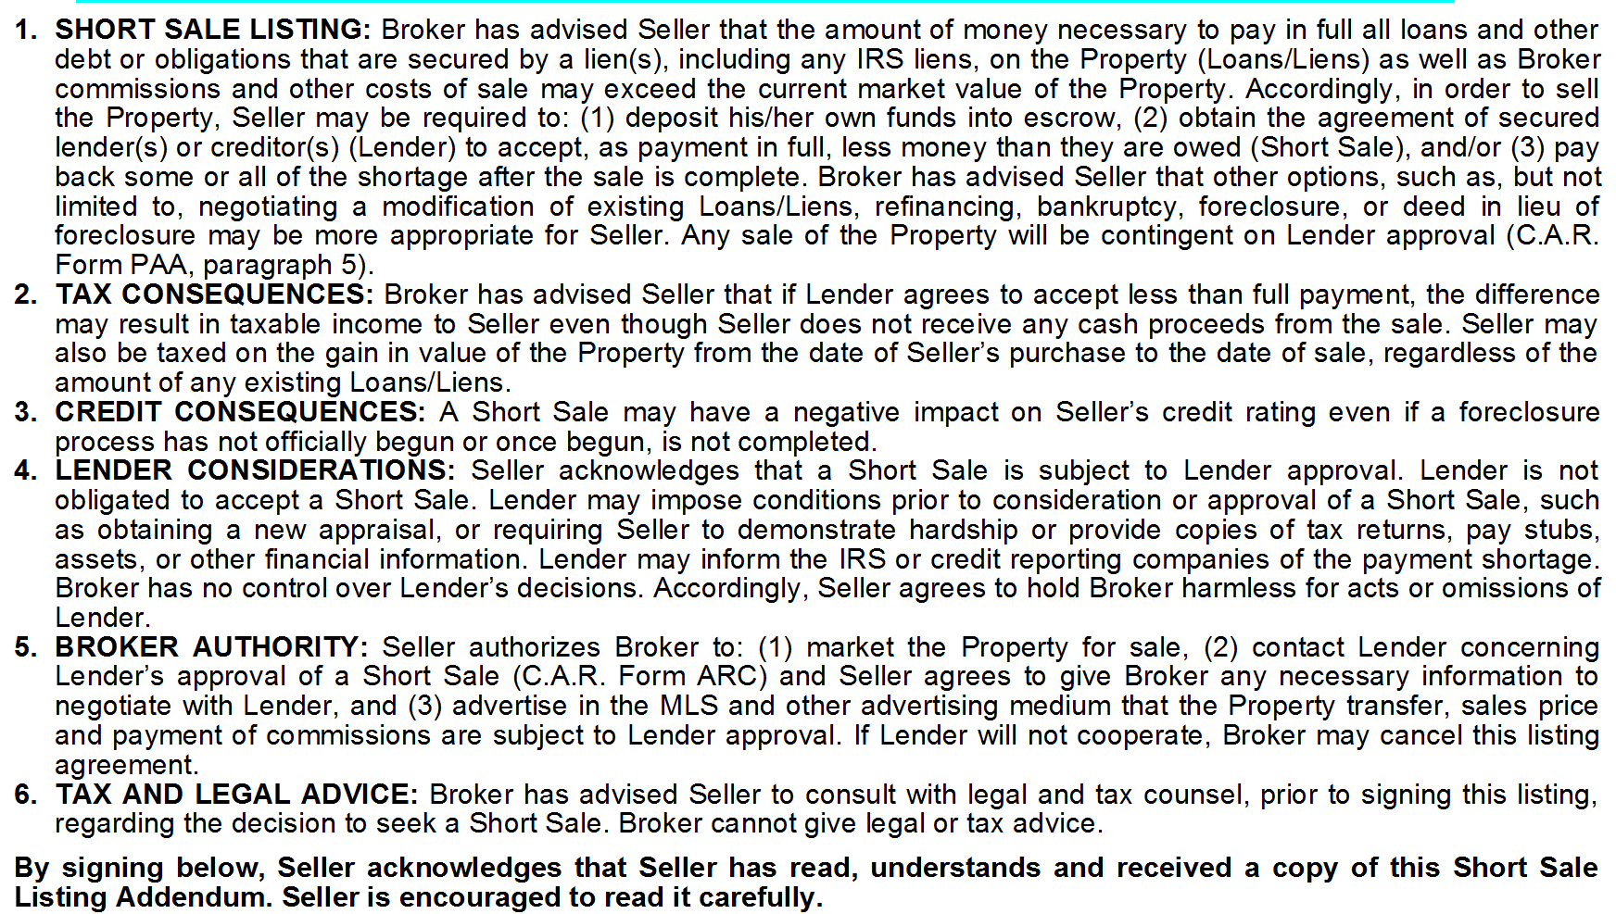

        - Pricing: It makes no sense in a short sale setting to start with an unreasonably high price. Some sellers will ask that you price the property at a “break-even” price for them initially. Use your best judgment, and follow your broker’s policies and procedures, but know that a price that attracts no offers will hurt your seller. If the foreclosure clock is already running, you may run out of time. Price the home at a realistic market price today. Adjust the price quickly if you see no activity or if you have no offers. To make the short sale work, you will need to get an offer to the lender quickly.

        - Commissions: Short sales present a special problem with conditional compensation being offered to a cooperating broker. As a listing agent, you are not entirely sure what your commission will be until the terms of a short sale are approved by the lender. Your MLS may have adopted NAR-approved language such as the following based upon changes adopted by NAR at the May, 2008 meeting:

Lender Approval Listings
Multiple Listing Services must give participants the ability to disclose to other participants any potential for a short sale. As used in these rules, short sales are defined as a transaction where title transfers; where the sale price is insufficient to pay the total of all liens and costs of sale; and where the seller does not bring sufficient liquid assets to the closing to cure all deficiencies. Multiple Listing Services may, as a matter of local discretion, require participants to disclose potential short sales when participants know a transaction is a potential short sale. In any instance where a participant discloses a potential short sale, they must also be permitted to communicate to other participants how any reduction in the gross commission established in the listing contract required by the lender as a condition of approving the sale will be apportioned between listing and cooperating participants. All confidential disclosures and confidential information related to short sales must be communicated through dedicated fields or confidential “remarks” available only to participants and subscribers.

Multiple Listing Services that permit, but do not require, participants to disclose potential short sales should adopt the following rule:

Section 5.0.1: Participants may, but are not required to, disclose potential short sales to other participants and subscribers. When disclosed, participants may, at their discretion, advise other participants whether and how any reduction in the gross commission established in the listing contract, required by the lender as a condition of approving the sale, will be apportioned between listing and cooperating participants.

Alternatively, Multiple Listing Services that require participants to disclose potential short sales should adopt the following rule:

Section 5.0.1: Participants must disclose potential short sales when reasonably known to the listing participants. When disclosed, participants may, at their discretion, advise other participants whether and how any reduction in the gross commission established in the listing agreement, required by the lender as a condition of approving the sale, will be apportioned between listing and cooperating participants.

        - Marketing: Both for the seller’s sake and to generate lender confidence, your short sale listings should be aggressively marketed. Whatever you would do for an ordinary listing, you should do for a short sale listing. Use multiple pictures, virtual tours, websites, and advertising as appropriate. You may want to accelerate the marketing if there is a foreclosure deadline looming. The lender will need to understand that you have done everything possible to sell the property at the highest price. The lender is not your client. You represent the seller, but everybody should understand that the lender is the true decision-maker. You will want to include the marketing history in the short sale package. Once again, if you have no offers within a reasonable time, adjust the price.

      - The lender is presented with an offer, accepted by the seller, along with a completed short sale package, hardship letter, and narrative explaining why the short sale is necessary and desirable.

        - The Offer

          - The ideal offer should be from a prequalified or preapproved buyer, with no unusual contingencies, such as the sale of the buyer’s existing residence. It should be flexible in terms of closing. The ideal offer might provide “The close of escrow to occur 30 days after buyer’s receipt of acceptance of the short sale by the lender”. The ideal buyer is willing to be patient. Of course, not all offers will be ideal. If you receive a very low offer, you may wish to attempt to negotiate it between the seller and the buyer as in an ordinary sale setting. Certainly you should counter terms that affect the seller in a negative way, such as early possession without compensation or inclusion of seller’s personal property. Remember that it is the seller who “accepts” the offer. Once the offer is fully negotiated between buyer and seller, it should be signed by both, subject to the approval by the lender as discussed elsewhere in this document. Recognize that lenders will want to see “as-is” offers without credits for repair or closing costs paid to buyers. Policies regarding short sale counter offers vary widely around the country, and also between brokers. Experience suggests that if you receive an offer on the low side of “reasonable” from a qualified buyer, you may still want to pass the offer along to the lender. In a short sale it is more important to get the lender a bona fide offer than it is to negotiate the perfect sale price. The very fact that an offer is presented to the lender for approval may persuade the lender to put the foreclosure process on hold, at least temporarily. The lender will have every opportunity to disapprove the offer and request a different price. Of course, just as in a traditional sale, all offers you receive must be presented to the seller throughout the course of your agency agreement.

          - If your state or local Association of REALTORS®, or your broker, provides a short sale addendum, use it in any counteroffer you make. It is designed to protect the seller against liability to the buyer in the event the lender disapproves the short sale. Here are some typical provisions from the California Association of REALTORS® Short Sale Addendum:
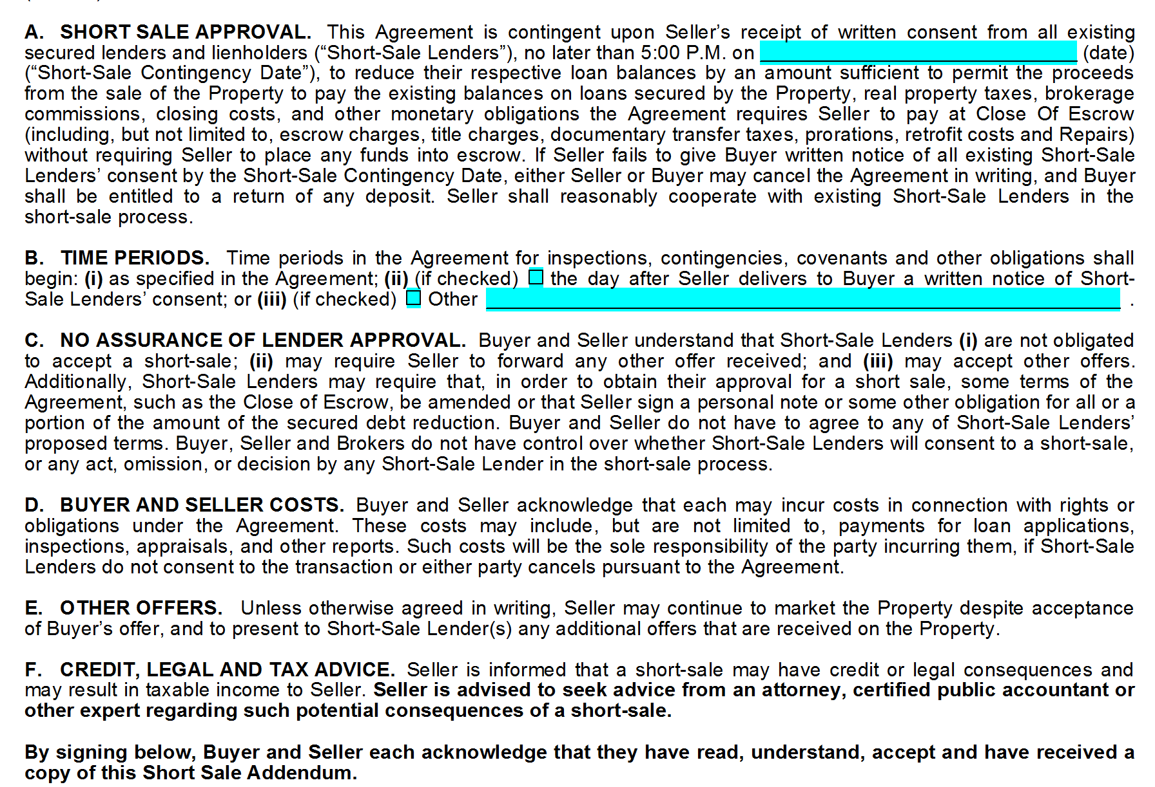

If you do not have such an addendum readily available, you may wish to ask your broker for similar language you can use in a counter offer.

        - The Completed Hardship Letter, Short Sale Package, and Narrative

          - Every lender is different, and each short sale package can be different as well. You may choose to submit most of the package to the lender when you obtain the listing, and then pass along the offer, or you may wait until you have an offer to submit a complete package. The following are the most common elements. Some will be required, and some are advisable because they help you explain to the lender why the short sale is a good alternative to foreclosure:

            - A hardship letter written by the seller describing the seller’s circumstances. The seller should be as persuasive as possible in describing why the seller is in no position to continue with his or her financial obligations to the lender. This letter can make or break the short sale. The reasons given by the seller should be compelling and the seller should be both honest and frank in their disclosures to the lender. Include corroborating material. If the seller was fired, include the termination letter. If the seller has medical bills, summarize them. If the seller is ill or disabled, the seller should explain how that has made it impossible for the seller to keep the property. If there are tax problems, the seller should describe and document them. If the property was damaged and not covered by insurance, as in several recent natural disasters, the seller should document the damage and the denial of the claim.

            - A copy of the purchase contract and all supporting documents signed by both the buyer and seller.

            - Written proof of the buyer's ability to purchase the property, i.e., a completed loan application, pre-approval by a lender or evidence of cash on hand (a current bank statement).

            - A copy of the certified escrow instructions.

            - A preliminary title report if applicable in your state.

            - An estimated net/closing statement (HUD-1) certified by an escrow officer who is acceptable to the lender. It is very important that this estimate be as complete and accurate as possible. Many lenders will reference the closing statement in their acceptance or rejection. You may receive an approval that states “Lender will accept net proceeds of no less than $273,565 no later than November 30, 2009”. If the estimate of net proceeds is wrong for any reason, you may have to attempt to renegotiate with the lender.

            - A completed and signed IRS Form 4506, "Request for Copy of Tax Form”.

            - A completed and signed personal financial worksheet. This will include assets such as other real estate, stocks, bonds, 401Ks, etc.

            - Tax returns for the previous two years.

            - Employment paycheck stubs for the past two months.

            - Profit and Loss statement (if the seller is self-employed)

            - Bank statements for the past two to three months.

            - A completed Short Sale Application if the lender provides one. Many don’t.

            - Your CMA/BPO with supporting sales data. You want to show that the offer you are presenting is the best market price offer the lender is likely to receive.

            - A short narrative, written by you, about the market and market trends in the immediate area of the property being sold. Highlight such data as average time on the market, number of short sale and REO listings in the MLS and price trends. Support your conclusions with material such as recent economic data and newspaper articles. The decision maker may well be in another state and will not necessarily understand why the property is suddenly worth less than the loan.

            - Your marketing history, showings, and feedback. Here again, you need to show the lender that you have made a real effort to get the highest price. They must understand that you have done a better job than they would have and that you have presented them with a quick and attractive solution to a deteriorating situation.

            - A formal request signed by the seller that the short sale be approved as submitted.

*Important Note: If there are multiple loans, you will repeat this process for each lender. It can be especially difficult to obtain a short sale approval from a second trust deed holder or other junior lienholder that is “wiped out” in a short sale. You will probably need to request that the first trust deed or mortgage holder offer at least a symbolic sum to the second trust deed holder to secure an approval. Anecdotally, second trust deed holders have recently been accepting partial payments as low as $5,000 on trust deeds of $100,000 or more.

        - Following Up. Once you have submitted the short sale package, stay in touch with the lender every day if possible. Make sure they acknowledge that the package is complete. Try to talk to the same person in the Loss Mitigation Department each time and document your conversations. This is not a happy decision for the lender. It will get shoved to the bottom of the to-do list over and over again. Lenders are infamous for “losing” short sale paperwork. Keep the seller and the buyer’s agent up to date. If there is a drop-dead time limit to the offer, remind the lender of it often.

  - Subsequent Offers.

    - There are different opinions and practices concerning whether to submit all offers received to the lender, or whether to limit the submission to the first offer the seller accepts. Many lenders will require in writing that all offers be submitted, as a condition of reviewing the short sale package. Consult with your broker concerning the broker’s policy regarding subsequent offers. Remember, once again, that all offers must be submitted to the seller, even if they are not then submitted to the lender.

    - In some areas, agents are simply submitting all offers to the lender without having the seller negotiate or accept any particular offer. Recognize that, without an accepted offer signed by both buyer and seller, you will not have a contract even if the lender approves. This approach presents certain practical and risk management issues. Consult with your broker about this practice if it appears to be common in your area, or if you are inclined to follow the practice.

- The Lender Response and the Close of Escrow

  - The lender can do one of several things.

    - Ignore the offer. (This happens.)
    - Refuse the offer, either with or without an indication of what net proceeds would be acceptable.
    - Ask the seller to bring some or all of the shortfall to escrow. This is a typical first response. If the seller is unable or unwilling to do so, you will need to contact the lender immediately with a letter from the seller to that effect.
    - Approve the offer.

  - If the lender refuses the offer, try to determine the net proceeds the lender would accept. Go back to the buyer and see if he or she will increase the offer to provide those proceeds. This process can be similar to any counteroffer situation, but it takes more time. If the buyer refuses, obtain a cancellation and go your back-up buyers (if any) in order. If there are no back-up offers, ask the lender to give you some time to place the property in the MLS as an “approved short sale” at the price and terms the lender will accept. If you then obtain a buyer who agrees to that price and those terms, you can proceed to close normally. Note that you may need a new approval from the lender even if the price and terms are exactly the same. Check with the lender.

  - If the lender approves the offer. It will typically be in the form of a demand to escrow (and possibly to you) to the effect that the lender will accept no less than X dollars in proceeds no later than X date. The lender may also attempt to reduce your commission. You can certainly argue with the lender about this, but ultimately, the lender will decide. Fannie Mae has issued a written policy directing its servicers not to reduce commissions below the amount in the listing agreement (if that amount is 6% or less) (Announcement 09-03 (2/24/09)). Freddie Mac has informed NAR that it does not reduce commissions, and NAR has asked Freddie to confirm this by issuing a written policy. Remember that the lender is not accepting the offer, but is simply agreeing to a smaller payment that the lender would otherwise be entitled to. This is why it is so important that the estimated closing statement be accurate. If the lender approves the short sale, it will not care what problems you might have closing the escrow on time, or what unanticipated costs you face. There will simply be a dollar amount that will need to be available at the close of escrow. Once escrow has the approval letter, you can proceed to close in the ordinary way. The buyer may have requested in the purchase contract that the seller move prior to the close of escrow so there are no holdover or possession problems. Remember that the seller is responsible for all the usual disclosures in your state, county, and city. The seller is still the owner of the property and the seller will be conveying title. You will be responsible for all the usual duties of a real estate agent in your state, county, and city.

- Final Notes.

  - Be aware that the Loss Mitigation and Foreclosure Departments are often different entities, and are staffed by different individuals. The Foreclosure Department might not be aware of what the Loss Mitigation Department has agreed to. In some cases, this has led to the property being foreclosed even after the Loss Mitigation Department has agreed to a short sale. Try to speak with the foreclosure department directly if the foreclosure date is close to your estimated closing date.

Acknowledgements

David Silver Westrick and Bill Lublin served as principal authors of the two parts to this Exhibit. Appreciation is extended to the entire membership of the work group for their contributions, but special thanks go to James J. Tsighis, Terisita Bersach, K. Michelle Lind, Mariwyn Evans, M. Anthony Carr, Bob Hunt, Mildred Wilkins, and the Wisconsin, Utah, Colorado, California and Arizona Associations for providing valuable information on the short sale process.

Disclaimer: Nothing in these pages is intended to constitute legal advice. This material is intended to give real estate licensees an overview of the short sale process from the point of view of the real estate practitioner, some tools to help sellers through it, and a large dose of caution. A short sale or a foreclosure is a catastrophic event for any property owner, and has serious legal, credit, and tax implications. Always advise a property owner in writing to obtain legal, credit, and tax advice before undertaking a short sale.
Article 13 REALTORS® shall not engage in activities that constitute the unauthorized practice of law and shall recommend that legal counsel be obtained when the interest of any party to the transaction requires it.
Go to www.MakingHomeAffordable.gov for information about the Obama Administration’s refi and loan mod options.
There are tax consequences associated with these options, some of which have changed under the Mortgage Forgiveness Debt Relief Act of 2007, as amended by P.L 110-343 (10/3/08). Up to $2 million of qualifying mortgage debt forgiven on the taxpayer’s principal residence from January 1, through December 31, 2012 will not be treated as income for the taxpayer, subject to various restrictions. The limit is $1 million for a married person filing a separate return. Mortgage debt reduced (forgiven) through restructuring, such as a workout or a short sale, as well as mortgage debt forgiven in connection with a foreclosure, all qualify for the tax exclusion. The Act applies only to principal residences, not vacation homes or investment property. Also the exclusion applies only to “acquisition indebtedness”, which is generally defined as debt used to originally build, purchase, or improve a property. Although short sales tend to minimize the difference between what is owed and the proceeds turned over to the lender, thereby minimizing the taxable income potentially accruing to the seller, the possibility remains. Sellers should be advised to consult with tax or legal counsel regarding the impact of the new law and other tax rules on their circumstances.

