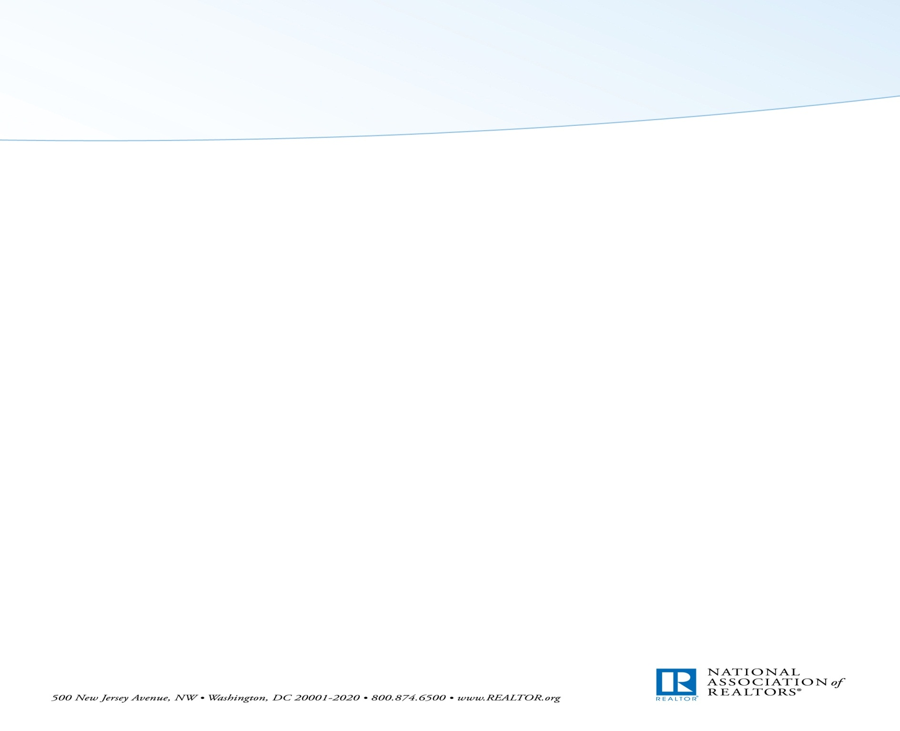
2017 NAR FPC Training and Federal Policy Conference
February 7 - 9, 2017

ATTENDEE LIST
(by alphabetical order)

A.

Cheryl Acker, Land Use Property Rights and Environment Committee Vice Chair
Carlotta Ackley, Resort and Second Home Real Estate Committee Vice Chair
Mario Arriaga, Global Business and Alliances Committee Vice Chair
Hope Atuel, AREAA Executive Director
Ibilola Audu Idea, Exchange Council for Brokers Chair

B.

Colleen Badagliacco, 2018 Vice President
Robert Bailey, Large Residential Firms Liaison
Fritzi Barbour, 2018 Law & Policy Liaison
Jeff Barnett, Large Residential Firms Real Estate Services Advisory Group Vice Chair
Tray Bates, 2018 REALTOR® Party Fundraising Liaison & 2017 Commercial Committee Chair
Genie Birch, Diversity Committee Chair
Larry Black, Conventional Financing and Policy Committee Vice Chair
Ryan Brashear, Federal Taxation Committee Vice Chair
Kevin Brown, 2018 Public & Federal Issues Liaison & 2017 Conventional Financing and Policy Committee Chair
Bill Brown, President
Leigh Brown, RPAC Trustees Fundraising Committee Vice Chair
Wendell Bullard, REALTOR® Party Community Outreach Liaison

C.

Krista Clark, 2018 Commercial & Business Specialties Liaison
Ronald Cooper, NAREB President
Beth Cristina, Commercial Committee Vice Chair

D.

Allan Daniels, Regulatory Issues Forum Vice Chair
Mary Dykstra, 2018 REALTOR® Party Community Engagement Liaison

F.

Don Faught, Public Policy Coordinating Committee Vice Chair
Drew Fishman, Federal Financing & Housing Policy Committee Chair

G.

Brandi Gabbard, Insurance Committee Vice Chair
Francois Gregoire, Real Property Valuation Forum Chair
Carol Griffith, REALTOR® Party Disbursement Liaison
Max Gurvitch, State and Local Issues Policy Committee Chair
Mabêl Guzmán, Vice President for Association Affairs

H.

Helen Hanna Casey, Corporate Ally Advisory Board Vice Chair
Iona Harrison, Federal Taxation Committee Chair
Daniel Hernandez, NAHREP
Richard Hernandez, NAHREP Treasurer
Connie Hettinga, Land Use Property Rights and Environment Committee Chair
Jeffrey Hicks, NAREB President- elect
Tim Hur, Diversity Committee Vice Chair

I.

Jim Imhoff, Corporate Ally Advisory Board Chair

J.

Nate Johnson, Smart Growth Advisory Board Chair
Rebecca Jones, Real Property Valuation Committee Vice Chair

K.

Tracy Kasper, REALTOR® Party Member Involvement Liaison
Larry Keating, 2018 Association Leadership Liaison
Mark Kitabayashi, Global Real Estate Liaison
John Kmiecik, Business Issues Policy Committee Vice Chair & Federal Technology Policy Advisory Board Chair
Christine Kutzkey, Business Issues Policy Committee Chair

L.

Steven Larue, Federal Independent Expenditures Advisory Board Vice Chair & RPAC Trustees Federal Disbursement Committee Vice Chair
Angie Lee, AREAA President-elect
Chelsea Locke, Federal Legislative and Political Forum Vice Chair

M.

Veronica Malolos, Housing Opportunity Committee Vice Chair
Bill Martin, Appointed State Association AE (PAAG Group)
Philip McGinnis, Federal Independent Expenditures Advisory Board Chair & RPAC Trustees Federal Disbursement Committee Chair
David McKey, Insurance Committee Chair
Bette McTamney, Idea Exchange Council for Brokers Vice Chair
Georgia Meacham, Smart Growth Advisory Board Vice Chair

M. (continued)

Elizabeth Mendenhall, President-Elect
Rei Mesa, Large Residential Firms Real Estate Services Advisory Group Chair
Pili Meyer, Global Business and Alliances Committee Chair
Julia Minto, 2018 REALTOR® Party Member Involvement Liaison
Kieyasien Moore, Commercial Legislation and Regulatory Advisory Board Vice Chair
Glenn Moore, Multicultural Real Estate Leadership Advisory Group Vice Chair
Ezekiel Morris, Multicultural Real Estate Leadership Advisory Group Immediate Past Chair

N.

Maura Neill , Federal Financing & Housing Policy Committee Vice Chair

O.

Allen Okamoto, Multicultural Real Estate Leadership Advisory Group AREAA member
Charlie Oppler, 2017 REALTOR® Party Director

P.

Christina Pappas, 2018 Large Firms & Industry Relations Liaison
Leonardo Pareja, NAHREP President-elect
Kenny Parcell, 2018 Vice President & 2017 REALTOR® Party Fundraising Liaison

R.

Tom Riley, Treasurer
Peter Ruffini, REALTOR® Party Member Involvement Committee Chair

S.

Eric Sain, 2018 REALTOR® Party Disbursement Liaison & 2017 Public Policy Coordinating Committee Chair
Tom Salomone, Immediate Past President
Michael Schoonover, Commercial Legislation and Regulatory Advisory Board Chair
Kevin Sears, 2017 Vice President for Government Affairs & Public Advocacy Advisory Group Chair
Brian Sears, Regulatory Issues Forum Chair
Baro Shalizi, Business Specialties Liaison
Vicky Silvano, 2018 Global Real Estate Liaison
Milton Shockley, Resort and Second Home Real Estate Committee Chair
John Smaby, Multicultural Real Estate Leadership Advisory Group & First Vice President Chair
Brenda Small, Public and Federal Issues Liaison
Dale Stinton, CEO
Hagan Stone, RPAC Trustees Fundraising Committee Chair
Ryan Swinney, State and Local Issues Policy Committee Vice Chair

T.

Randall Thomas, Real Property Valuation Committee Chair
Linda Trevor, REALTOR® Party Member Involvement Committee Vice Chair

U.

Laurie Urbigkit, Housing Opportunity Committee Chair

W.

Richard Waystack, CRS Regional Divisions Chair
Margo Wheeler Willis, 2018 REALTOR® Party Director
Donnell Williams, NAREB, First Vice President
Merle Whitehead, 2018 MLS & Data Management Liaison
Melvin Wilson, Federal Legislative and Political Forum Chair

Z.

Pat Zicarelli, 2018 Member Services Liaison
Deena Zimmerman, Commercial Liaison

