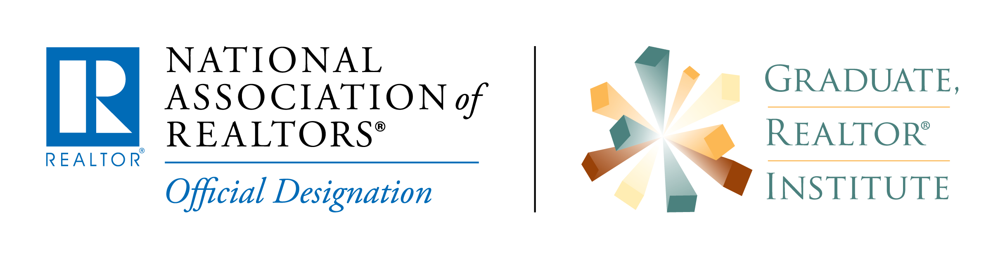
FOR IMMEDIATE RELEASE:
Contact:
Contact Person:
Company Name:
Telephone Number:
Fax Number:
Email Address:
Web site address:
_______________________________________________________________________
(Date)
A (Your STATE Association of REALTORS®) was recently awarded the Graduate, REALTOR® Institute (GRI) designation.
The (Local Board) member who completed the curriculum required to achieve the highly acclaimed designation is (Your Name) of (City). (He/She) joins other top producers in the residential real estate industry who hold the designation across the nation.
(Name) earned the “Graduate, REALTOR® Institute” (GRI) Designation by attending a minimum of 60 hours of classroom instruction, covering a variety of subjects including: contract law, professional standards, sales and marketing, finance, and risk reduction.
In addition, they have learned the fundamentals of brokerage and other areas of real estate specialization. With this designation and through increased awareness of current topics important to the real estate professional, such as legal issues, these REALTORS® can better serve prospective clients and customers.
The GRI designation sets the individuals who have attained it, apart from other practitioners because it indicates to the public that the individual has obtained a professional educational foundation on which to base the services they provide and that they are a member of the NATIONAL ASSOCIATION OF REALTORS®.
Obtaining the GRI designation is a beneficial way for a REALTOR® to advance their professional image. The extra measure of knowledge and prestige achieved by completing this course work is a tool that will advance a career in real estate on attracting and building new business.
The REALTOR® Institute has been in existence for more than twenty-five years and has graduated thousands of REALTORS®.
REALTORS® or consumers interested in learning more about the program may visit www.Realtor.org/GRI.

