FOR IMMEDIATE RELEASE:
Contact:
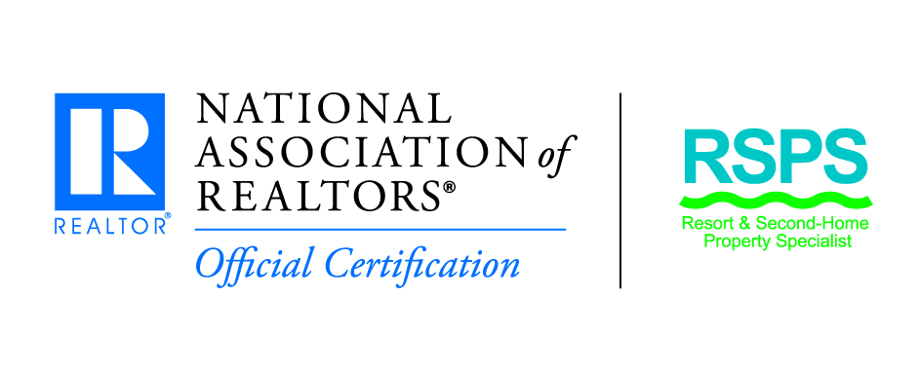
Contact Person:
Company Name:
Telephone Number:
Fax Number:
Email Address:
Web site address:

____________________________________________________________________________________

(Date)
(Your Town) – (Your Name) with (_______Association of REALTORS®) has been awarded the Resort and Second-Home Property Specialist (RSPS) Certification. The RSPS Certification is a nationally-recognized certification awarded by the National Association of REALTORS® to real estate professionals who wish to demonstrate and promote – to consumers and their peers alike – their expertise in the resort and second home specialty.
(Your name) joins more than 1,600 real estate professionals who have earned the RSPS certification. REALTORS® who receive the RSPS certification have successfully completed the Resort & Second-Home Markets Course along with three webinars in the field of resort and second home real estate. (He/She) now joins other real estate professionals who specialize in buying, selling, or managing second homes in a resort, recreational, and/or vacation destination and properties for investment, development, or retirement.
“The RSPS certification program offers one of the most powerful networking opportunities,” said David Biechele, 2013 chair of the NAR’s Resort and Second Home Real Estate Committee and an RSPS. “You will connect with agents across the country and share your local knowledge to attain referrals. In the process you will educate yourself above your competitors by attaining insight of other second home and resort areas in the United States and abroad. You can connect through the many social media sites or in person at the Resort and Second Home Networking Reception.”
REALTORS® or consumers interested in learning more about the program may log on to www.Realtor.org/Resort or contact NAR Resort Specialties at 800/874-6500, Ext. 8268.

