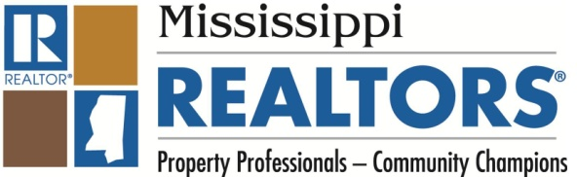

State Leadership Idea Exchange Council
Report from the Mississippi REALTORS®
October, 2013

Under the leadership of 2014 President Ken Austin, Mississippi REALTORS® have been focused this year on "One Family, One Goal, Success." We have enjoyed success in a number of areas this year, but probably our most noteworthy success story is a result of a challenge issued by President Austin. For the past several years, Mississippi has recruited a large number of Major Donors to RPAC, with numbers near or just above 100 Major Investors for our small state. In 2013, President Austin wanted to continue our push for Major Donors, but he also wanted to emphasize the importance of the Fair Share contribution. He issued a challenge to each local board to work toward 51% Fair Share participation among their membership. (It should be noted that Fair Share levels in Mississippi are higher than the $15 level set by RPAC. Our Fair Share levels are $25 for salespeople and $99 for designated brokers). Local boards throughout the state enthusiastically embraced this challenge. President Austin enlisted the help of our MARPAC Trustees to assist, and they stepped up to the plate to make phone calls and send emails to encourage contributions from members of their assigned boards. Two of those Trustees, Lisa Hollister and Chris Wilson, received an RPAC Fundraising Grant from NAR and traveled to 15 different local boards with a unique presentation emphasizing the collective impact of Fair Share contributions. President Austin attended many of these sessions to reinforce their message and followed up with personal phone calls to local board leaders in many areas of the state. Local board AEs, officers and MAR's staff also worked diligently to help meet this challenge. MAR's Governmental Affairs Director worked with NAR to utilize Aristotle software and send targeted emails to REALTORS® who had not yet contributed. A Web page was created and regularly updated, http://www.fairshare2013.com, so that local boards could track their progress toward the goal.

The results of all of this focused activity:
- Fifteen of Mississippi's 21 local boards either met or exceeded the Fair Share participation goal of 51%.
- Although not all local boards met the 51% goal, stepped-up efforts in those boards yielded results too as Fair Share participation was up in 100% of Mississippi's local boards over 2012.
- Statewide totals reveal that 51% of Mississippi's REALTORS® contributed at least their Fair Share.

