Delaware Association of REALTORS®
Small State Idea Exchange
Discussion Report
2013 REALTORS® Annual Conference

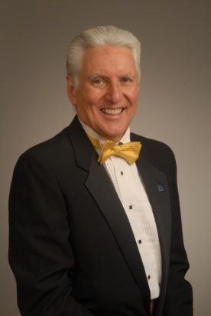
Gail Renulfi, President Rob Harman-President elect
Prudential Fox & Roach Alliance Real Estate Professionals
88 Lantana Drive 30613 Highway US 13
Hockessin, DE 19707 Laurel, DE 19956

Idea Exchange:

With the inclusion of the My REALTOR® Party resources, we updated our Public Policy manual to include interaction with the consumer as well as our members. We also developed a legislative issues work sheet to help us stay on track during our policy discussions. Many times committee members want to move forward on an issue and take a vote before fully discussing the desired outcomes. This form lets us know how we will proceed, who we will include as well as other variables when seeking to introduce or change legislation or a regulation. Going through all the items on the forms keeps us focused on utilizing DAR as well as NAR resources. Even though it is a simple format, it helps to keep us on track and not let the more vocal members decide policy without a thorough vetting.

