News Release
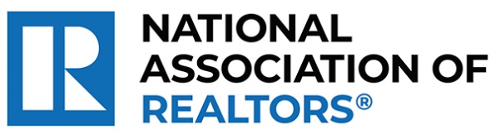 | MEDIA COMMUNICATIONS  For further information contact:  Spencer High, 202/383-1051  shigh@nar.realtor
Realtor® from Palm Coast Wins National Award for Providing At-Risk Foster Children a Supportive Home
WASHINGTON (October 5, 2023) – Realtor® Sandra Shank with TAG Ventures Real Estate Services Co. in Palm Coast is one of five winners chosen as a recipient of the National Association of Realtors® Good Neighbor Awards.
In 2003, Shank opened Abundant Life Ministries–Hope House Inc. to give troubled teenage boys in Florida’s foster care system a supportive foundation. For 20 years, she has housed and mentored 300 of the most vulnerable residents, with current plans to break ground on an affordable housing complex offering holistic care services to families in need.
“As we honor Sandra, we are reminded of the broader purpose that unites us in the real estate profession,” said NAR President Tracy Kasper, a Realtor® from Nampa, Idaho, and broker-owner of Berkshire Hathaway HomeServices Silverhawk Realty. “Beyond sales and contracts, it’s the people, their stories and the shared dreams that matter. She is making a difference in her community and improving lives every single day, underlining the true spirit of community engagement.”
To view an electronic press kit for Sanda Shank, including downloadable photos and videos, visit https://www.nar.realtor/good-neighbor-awards/sandra-shank-media-kit.
“It is truly a blessing and honor for the impact of my volunteer work to be recognized by fellow real estate agents,” said Sandra Shank. “Oftentimes, when people think of agents, they think of closing a transaction, but this extends far beyond that. It underscores the immeasurable value of transforming lives through service to humanity, and I am so proud and grateful to have this opportunity.”
Shank and the other four Good Neighbor Award winners will receive a $10,000 grant for their charity and be featured in the fall 2023 issue of REALTOR® Magazine. NAR will formally present each with their award on November 15 during NAR NXT, the association’s annual conference that will take place in Anaheim this year.
NAR’s Good Neighbor Awards is supported by primary sponsor Realtor.com® as well as the Center for REALTOR® Development.
“This year’s Good Neighbor Award winners continue the tradition of raising the bar on what’s possible through giving back,” said Realtor.com® CMO Mickey Neuberger. “Their stories have moved us at Realtor.com® and we are honored to be long-time sponsors of the Good Neighbor Awards program.”
The National Association of Realtors® is America’s largest trade association, representing more than 1.5 million members involved in all aspects of the residential and commercial real estate industries. The term Realtor® is a registered collective membership mark that identifies a real estate professional who is a member of the National Association of Realtors® and subscribes to its strict Code of Ethics.
# # #
Information about NAR is available at nar.realtor. This and other news releases are posted in the newsroom at nar.realtor/newsroom.

