News Release
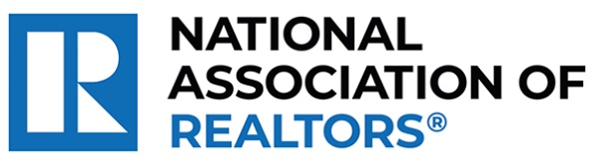 | MEDIA COMMUNICATIONS  For further information contact:  Spencer High, 202/383-1051  shigh@nar.realtor
Realtor® from Fort Lauderdale Wins National Award for Matching Unsold Retail Merchandise with Charitable Causes
WASHINGTON (October 5, 2023) – Realtor® Kasia Maslanka with Douglas Elliman in Fort Lauderdale is one of five winners chosen as a recipient of the National Association of Realtors® Good Neighbor Awards.
Maslanka co-founded Morningday Community Solutions to redirect overstocked or returned excess merchandise from retail businesses to nonprofits and people in need. Over 13 years, they have saved nonprofits $10 million in spending and diverted more than 500 tons of unused products from landfills each year.
“As we honor Kasia, we are reminded of the broader purpose that unites us in the real estate profession,” said NAR President Tracy Kasper, a Realtor® from Nampa, Idaho, and broker-owner of Berkshire Hathaway HomeServices Silverhawk Realty. “Beyond sales and contracts, it’s the people, their stories and the shared dreams that matter. She is making a difference in her community and improving lives every single day, underlining the true spirit of community engagement.”
To view an electronic press kit for Kasia, including downloadable photos and videos, visit https://www.nar.realtor/good-neighbor-awards/kasia-maslanka-media-kit.
“I’m deeply honored to receive this award,” said Maslanka. “This recognition highlights the power of community and the importance of giving back. It’s a testament to our ability to foster profound change and strengthen bonds, and I’m now even more inspired to continue with my philanthropic efforts to foster positive change in my community.”
Maslanka and the other four Good Neighbor Award winners will receive a $10,000 grant for their charity and be featured in the fall 2023 issue of REALTOR® Magazine. NAR will formally present each with their award on November 15 during NAR NXT, the association’s annual conference that will take place in Anaheim this year.
NAR’s Good Neighbor Awards is supported by primary sponsor Realtor.com® as well as the Center for REALTOR® Development.
“This year’s Good Neighbor Award winners continue the tradition of raising the bar on what’s possible through giving back,” said Realtor.com® CMO Mickey Neuberger. “Their stories have moved us at Realtor.com®, and they’ve inspired everyone who voted for their Web Choice Favorite. We are honored to be long-time sponsors of the Good Neighbor Awards program.”
The National Association of Realtors® is America’s largest trade association, representing more than 1.5 million members involved in all aspects of the residential and commercial real estate industries. The term Realtor® is a registered collective membership mark that identifies a real estate professional who is a member of the National Association of Realtors® and subscribes to its strict Code of Ethics.
# # #
Information about NAR is available at nar.realtor. This and other news releases are posted in the newsroom at nar.realtor/newsroom.

