News Release
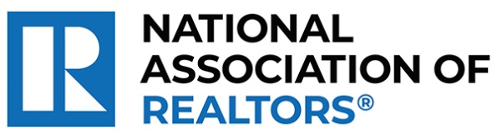 | MEDIA COMMUNICATIONS  For further information contact:  Spencer High, 202/383-1051  shigh@nar.realtor
Realtors® from Helena Win National Award for Giving Young Adults a Second Chance After Homelessness
WASHINGTON (October 5, 2023) – Realtors® Anita Sherley and Jay Sherley with Big Sky Brokers LLC in Helana are one of the winners chosen as a recipient of the National Association of Realtors® Good Neighbor Awards.
The Sherleys provide stable housing and mentoring to at-risk young men and women recently released from jail or too old for foster care, those typically at higher risks of homelessness. In the 16 years since they founded Life Houses Inc., they have helped more than 200 at-risk young adults build life skills to transition to productive, goal-oriented lives of purpose.
“As we honor Anita and Jay, we are reminded of the broader purpose that unites us in the real estate profession,” said NAR President Tracy Kasper, a Realtor® from Nampa, Idaho, and broker-owner of Berkshire Hathaway HomeServices Silverhawk Realty. “Beyond sales and contracts, it’s the people, their stories and the shared dreams that matter. They are making a difference in their community and improving lives every single day, underlining the true spirit of community engagement.”
To view an electronic press kit for Anita and Jay Sherley, including downloadable photos and videos, visit https://www.nar.realtor/good-neighbor-awards/anita-jay-sherley-media-kit.
“Being honored by the real estate community in this way is both humbling and mind-blowing,” said Anita Sherley. “Our unwavering passion over the years has been met with such genuine kindness and enthusiasm from our peers, making the entire journey truly remarkable.”
The Sherleys and the other four Good Neighbor Award winners will receive a $10,000 grant for their charity and be featured in the fall 2023 issue of REALTOR® Magazine. NAR will formally present each with their award on November 15 during NAR NXT, the association’s annual conference that will take place in Anaheim this year.
NAR’s Good Neighbor Awards is supported by primary sponsor Realtor.com® as well as the Center for REALTOR® Development. In September, Realtor.com® invited the public to vote for their favorite of the 10 finalists. The Sherleys ranked first in the Web Choice Favorite voting and will receive a bonus $2,500 grant for their charity.
“This year’s Good Neighbor Award winners continue the tradition of raising the bar on what’s possible through giving back,” said Realtor.com® CMO Mickey Neuberger. “Their stories have moved us at Realtor.com® and we are honored to be long-time sponsors of the Good Neighbor Awards program.”
The National Association of Realtors® is America’s largest trade association, representing more than 1.5 million members involved in all aspects of the residential and commercial real estate industries. The term Realtor® is a registered collective membership mark that identifies a real estate professional who is a member of the National Association of Realtors® and subscribes to its strict Code of Ethics.
# # #
Information about NAR is available at nar.realtor. This and other news releases are posted in the newsroom at nar.realtor/newsroom.

