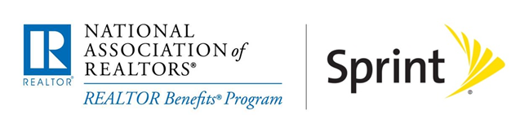

NAR Partner Benefits Program with Sprint
Frequently Asked Questions

What is the benefit program with Sprint?
Through the REALTOR Benefits® Program, NAR has negotiated a discount of up to 18% on eligible Sprint wireless plans for NAR members, and a 20% discount on select accessories.

Which plans are eligible for the discount?
Corporate Liable Discount  on selected voice and data plans | Individual Liable Employee Discount  on selected voice and data plans:
Up to 18% | Up to 18%

How do I validate my membership?
You can validate your membership online at www.sprint.com/verify. A printable form and fax instructions are also available on the site. Enter your Sprint phone number and then click on the “Fax or Upload your verification” link on the right hand side. Follow the instructions to upload a copy of your NAR membership card and click submit. A copy of your NAR membership card can be downloaded from the REALTOR.org Member Center at http://membercenter.realtor.org/. Sprint will send you an email confirming your eligibility within about 3 days and the discount will appear on your statement within 1-2 billing cycles.

I already have Sprint service but am not getting a discount. Can I still get the NAR Benefit from Sprint?
Yes, simply follow the instructions above to complete the process.

I already get a discount on my Sprint service through my spouse’s company but it is not as good as the NAR discount, can I switch over to the NAR discount?
If you are already getting a discount and are in a 2-year contract, Sprint requires that you complete the contract under that discount program before you move to the NAR Partner Benefit. In addition, the Sprint account name must match the eligible NAR Member name. Once that contract is completed, you are free to go through the regular enrollment process to get the NAR discount.

Can my family take advantage of the NAR discount as well?
Any NAR Member can purchase devices for family members. When you sign up with Sprint, they will set up your account as approved for a number of lines based on credit score. As long as the name on the account matches the NAR Member, you may add family members to your account and get the NAR discount on eligible plans.

I have a business account with Sprint. Can I still get the NAR discount?
Yes, please contact Jerry Kaufmann (Jerry.F.Kaufmann@sprint.com) for more information.

Who should I contact if I have additional questions on this program?
Please contact one of these Sprint contacts:

Sarah Ward
Project Program Manager
Office: 281-808-2799
Email: Sarah.Ward@sprint.com

Jerry Kaufmann
Business Relationship Manager
Office: 913-439-5886
Email: Jerry.F.Kaufmann@sprint.com

