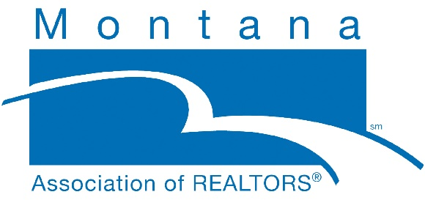

TITLE: RPAC Specialist
LOCATION: HELENA, MONTANA
REPORTS TO: CHIEF EXECUTIVE OFFICER (CEO)
DESCRIPTION OF THE ORGANIZATION:
The Montana Association of REALTORS® (MAR) is the voice for real estate in Montana. We represent more than 5,000 members involved in all aspects of the residential and commercial real estate markets throughout Montana.
POSITION SUMMARY:
The REALTOR® Political Action Committee (RPAC) Specialist is responsible for managing and administering political investment activities for the association.

ESSENTIAL FUNCTIONS:
- Committee Liaison: Staff liaison to the RPAC Trustees Committee. Work with the committee chair to set agendas, invite guest speakers, and educate the committee. Work with committee to identify political victories for use to encourage member investments, recognition efforts, local strategies, and to develop minutes. Update the committee on goal status, along with federal and state collaborative efforts.
- Promotion Plan for Goal: Works with the Chief Staff Executive (CSE), GAD, and Federal contact, to develop an annual plan that will allow the association to meet (or exceed) participation, investment, and major donor goals. Execute, plan and ensure compliance with state and federal law.
  - Assist local REALTOR® boards in their efforts regarding RPAC fundraising, IMF fundraising, and Independent Expenditure Campaigns.
  - Assist in training local board staff in RPAC fundraising, as well as the rules and reporting requirements related to fundraising.
- Candidate Funding: Work with Candidate Selection Taskforce (or RPAC Committee) to build a candidate support process that includes the creation of a candidate questionnaire for distribution to candidates, briefing materials for the task force or committee, candidate interviews, and identification process of candidates to support and/or fund.
- Education: Write articles for the newsletter, blog, and uses other communication vehicles to educate the association members about the value of RPAC, legislative victories, and supported candidates via a candidate slate sent to members before each election.
- Branding/Recognition: Work with the Communications Director to educate the membership about RPAC, secure opportunities at association events (e.g., promotion table) to promote RPAC, and promote investors and major donors.
- Core Standards: Assists the GAD to ensure that the association meets NAR’s Core Standards advocacy compliance criteria annually.
- Administrative: Assist Business Manager with maintaining records and filing required campaign finance reports with the office of Commissioner of Political Practices. Assist Business Manager with the RPAC and IMF awards and recognition programs. Provide administrative support to Government Affairs Directors.
OTHER:
- Attend Montana Association of REALTORS® meetings as requested. Perform other duties as assigned by the Government Affairs Director and the CEO.
QUALIFICATIONS:
- Bachelor’s degree preferred.
- 2-3 years’ experience in campaign, fundraising, or public affairs.
- Excellent interpersonal skills.
- Effective communication skills, both verbal and in written.
- Ability to take complicated information and communicate it simply.
- Highly organized.
- Experience managing volunteers.

WORK ENVIRONMENT AND PHYSICAL DEMANDS:
Work hours as noted in the policy manual, except for occasional evening and weekend activities. Travel out of town once or twice annually for two to four days. In addition:
- Ability to walk, stand, and sit (including on the floor) for long periods.
- Must be able to lift and carry supplies weighing up to 20 pounds.
- Ability to stand or sit while maintaining alertness for several hours at a time.
- Position may require bending, leaning, kneeling, and walking.
- Ability to speak concisely and effectively communicate.
- Visual and auditory ability to respond to critical situations and physical ability to act swiftly in an emergency.
- Ability to view/enter data for long periods.

To apply, please submit your cover letter and resume to kaaren@montanarealtors.org.

