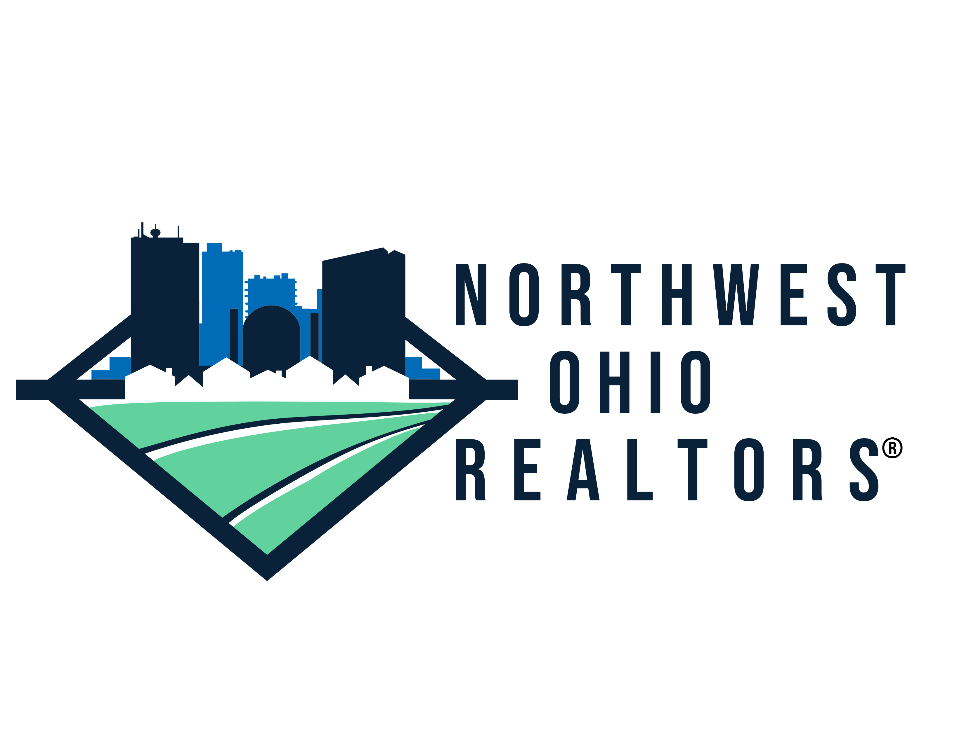

Northwest Ohio REALTORS®
COMMUNICATIONS DIRECTOR

ORGANIZATION DESCRIPTION:
Northwest Ohio REALTORS® (NOR), an association of real estate professionals who are dedicated to serving the needs of home sellers and buyers in Northwest Ohio. We serve over 2,000 members by providing training, benefits and resources to help them excel in the real estate industry. NOR is looking for a Communications Director to manage its multifaceted communications.

POSITION OVERVIEW
The Communications Director manages all marketing, public relations, and other Association communications. The Director will also coordinate events and other duties as assigned by the CEO. The ideal candidate must develop and implement strategies for the Association’s communications, collaborate with other stakeholders, stay abreast of current industry regulations, policies and national issues and be experienced in handling a wide range of communication related tasks. This person must be experienced with project management, meet established deadlines, and enjoy the challenges of supporting 2,100 members.

The ability to interact with staff and association leadership/volunteers (at all levels) with a high level of professionalism and confidentiality is crucial to this role. Expert level written, social media and communication skills, strong decision making ability and attention to detail are equally important.

ESSENTIAL DUTIES AND RESPONSIBILITIES
- Develop weekly electronic communication to membership
- Design and write NOR’s electronic magazine
- Create the NOR Annual Report
- Manage the NOR website
- Manage social networking sites including Facebook, Instagram, LinkedIn, Twitter and YouTube
- Take, edit and upload videos and pictures of NOR events and activities
- Coordinate events and other duties as assigned by the CEO

REQUIREMENTS
- Self-starter with innate and creative problem-solving skills
- Firm grasp of available tools and platforms in the social media space
- Website and web-based communication development and maintenance experience
- Knowledge of digital media and graphic design software
- Knowledge of photo and video editing software
- Excellent writing and communication skills in both print and electronic formats
- Ability to coordinate and execute multiple projects simultaneously
- Positive attitude and willing to support the team when needed

EDUCATION AND/OR EXPERIENCE
- Bachelor’s degree or equivalent experience
- Real Estate experience is helpful but not required

IMPORTANT NOTES
We are an EOE dedicated to a diverse work force and drug free environment.

