News Release

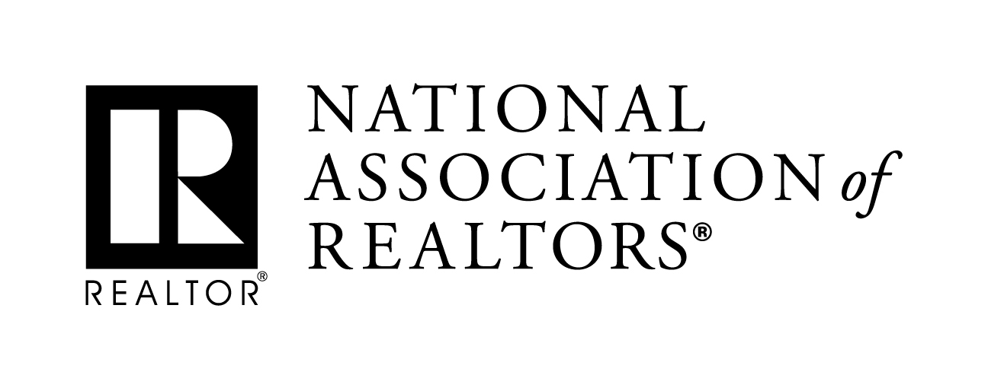 | MEDIA COMMUNICATIONS  XXXX, (XXX) XXX-XXX  xxxxx@xxxxxx.xxxx
Fill-in-the-Blank News Release Highlighting Local Realtor® Association
Meetings with Congressional Representatives

The following “fill-in-the-blank” news release is designed to help you gain publicity in your local news outlets following meetings with your Member of Congress during the August District Work period.

Place it on your company or local board/association letterhead with the blanks filled in as indicated.
- Include a contact name and number at the top of the release.
- Send the release to the appropriate editor/reporter at the outlet.
- Feel free to use NAR's logo in addition to your association’s logo, or simply replace this logo with yours
- If possible, your chances for exposure will increase significantly when a photo is provided to media, particularly those in small or medium sized outlets. A link to a collection on your association’s website is the most ideal way to accomplish this.

[Association of Realtors®] meets with [Congressman XX] to discuss [region’s] transportation infrastructure, impact on local housing market
[Your city (Date)] — Representatives from the [Local Association of Realtors®] today met with [Congressman/woman XX and members of his/her] staff at the [insert name of meeting space] in [Location]. While covering a variety of topics, [Xxxday’s] meeting focused on federal efforts to improve America’s transportation infrastructure while highlighting the potential impact of those investments on [local region’s] housing market.
The [local Association of Realtors®], along with the National Association of Realtors® in Washington, D.C., has been encouraging lawmakers in Congress to make genuine, responsible investments in America’s transportation network. Realtors® are currently advocating for two specific policy changes; urging reforms to modernize federal infrastructure funding and streamline federal permitting. The group argues these changes will increase efficiency and maximize America’s infrastructure funds.
“Even modest improvements to transportation infrastructure have shown to enhance property values in communities across the country,” said [Local Association President First Name Last Name]. “Right here in [local region], we know that these investments will directly and immediately impact people in every neighborhood, increasing property values, attracting new business opportunities and improving our overall quality of life. But without a clear plan of action, we jeopardize opportunities for economic growth and risk falling behind other regions of the country.”
[Local Association of Realtors®] and NAR support efforts to secure long-term funding sources for the Federal Highway Trust Fund. Various such proposals are being discussed by lawmakers in Washington, including an increase to the federal gas tax. The Realtor® groups also believe Congress must continue to foster innovative transportation enhancements led by the private sector.
“A robust, long-term federal infrastructure modernization program, combined with greater investment by state, local and private stakeholders, will help to ensure our infrastructure network is designed for the 21st century,” said [Local Association President Last Name]. “But without a serious commitment from federal lawmakers, we will not make the kind of progress we need to make.”
Finally, [Local Association of Realtors®] and NAR believe streamlining permitting for infrastructure projects will decrease costs and bring infrastructure-related projects to the market more quickly. The groups argue lawmakers should work to increase transparency while eliminating duplication in order to provide better outcomes for communities and neighborhoods.
“Over recent election cycles, voters throughout the country have made clear their desire to see lawmakers secure bipartisan infrastructure reform” said NAR President John Smaby, a Realtor® from Edina, Minnesota. “The National Association of Realtors®, together with our 1.3 million members across the country, understands the critical role infrastructure improvements play in maintaining property values, creating livable neighborhoods and developing communities in which businesses can succeed.”
[Your association or company boilerplate here.]
###

