News Release

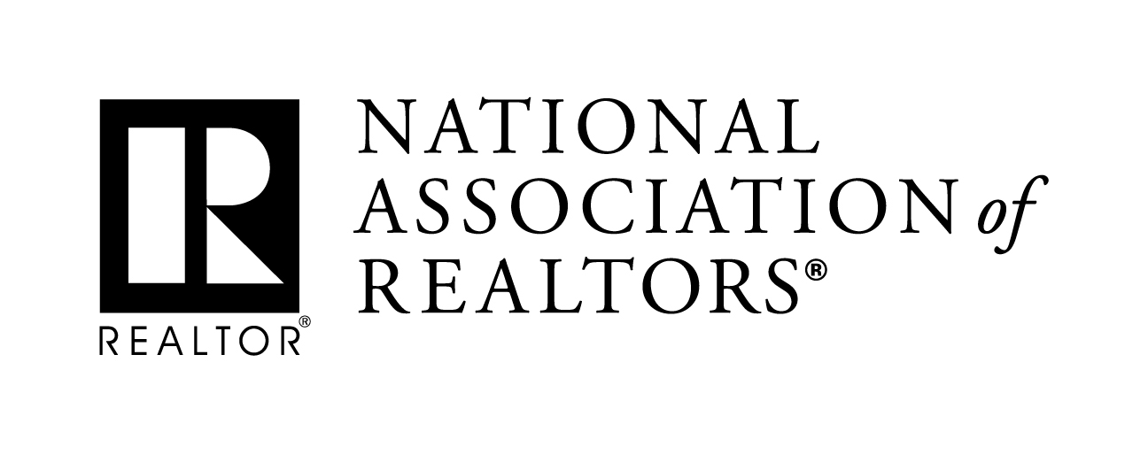 | MEDIA COMMUNICATIONS  XXXX, (XXX) XXX-XXX  xxxxx@xxxxxx.xxxx
Fill-in-the-Blank News Release Highlighting Local Realtor® Association
Meetings with Congressional Representatives

The following “fill-in-the-blank” news release is designed to help you gain publicity in your local news outlets for your meetings with local Members of Congress during the August District Work period.

Place it on your company or local board/association letterhead with the blanks filled in as indicated.
- Include a contact name and number at the top of the release.
- Send the release to the appropriate editor/reporter at the outlet.
- Feel free to use NAR's logo in addition to your association’s logo, or simply replace this logo with yours
- If possible, your chances for exposure will increase significantly if a photo is provided to media, particularly those with small or medium sized outlets. A link to a collection on your association’s website is the most ideal way to accomplish this.

[Local Association of Realtors®] discuss Fannie, Freddie reform with [Rep. XXX]
Realtors® outline U.S. housing finance system’s impact on [local region’s] housing market
[Your city (Date)] — Representatives from the [Local Association of Realtors®] today met with [Congressman/woman XX and members of his/her] staff at the [insert name of meeting space] in [Location]. While covering a variety of topics, [Xxx-day’s] meeting focused on efforts to secure the future of America’s housing finance system and highlight its impact on [local region’s] housing market.
The [Local Association of Realtors®], along with the National Association of Realtors® in Washington, D.C., has spent recent years urging Congress to make genuine movement toward long-term reform of Fannie Mae and Freddie Mac, also known as the Government Sponsored Entities, or GSEs.
“Because of the GSEs, homebuyers here in [local region] have equal access to a mortgage and pay nearly identical rates as those in Springfield, Missouri, Springfield, Massachusetts, and in countless communities across the country,” said [Local Association President First Name Last Name]. “Middle-class Americans have benefitted from this foundational mission of our housing finance system for over forty years. Those benefits will endure for decades to come if our leaders in Congress and the administration can agree on responsible system reforms.”
Under the Realtors®’ plan, Fannie Mae and Freddie Mac would operate as private, shareholder-owned utilities that would continue to purchase, guarantee and securitize single-family and multifamily mortgage loans.
“Our proposal for GSE reform offers a new utility model that highlights competition and learns from the failures of the pre-crisis system,” said NAR President John Smaby, a second-generation Realtor® from Edina, Minnesota. “Most importantly, as utilities, Fannie and Freddie’s foremost priority would be to serve the original public mission instituted by Congress – supporting a mortgage market that is accessible to all responsible homebuyers in times of both economic distress and prosperity.”
The White House is expected to unveil its detailed proposal for GSE reform sometime before the end of 2019. Until then, Realtors® remain engaged in the process and continue stressing the importance of a healthy housing finance system across rural and Middle America.
“Middle Class Americans should never pay more for or be unable to secure a mortgage simply because of where they live,” [Local Association President Last Name] concluded. “The Realtors® utility model will keep the promise lawmakers made to this country over 40 years ago, and will ensure the GSEs emerge stronger, healthier companies than they have ever been.”
[Your association or company boilerplate here.]
###

