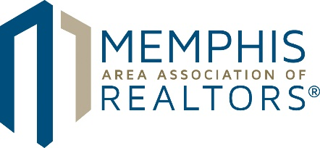

POSITION TITLE: MLS Project Manager & Trainer

POSITION SUMMARY: Assists with MLS Project Management and Member Training & Outreach. Responsible for assisting with operational issues, compliance, vendor contracts and providing support for the MLS system, while ensuring accuracy and usefulness for members.

SKILLS REQUIRED:
- Proficient in technology and computer programs
- Hight level of accuracy and detail when working on contracts and compliance
- Ability to multi-task and gracefully handle interruptions to workflow
- Service-oriented
- Clear and professional communication style and good interpersonal skills
- Flexible mindset and able to accommodate diverse learning styles
- Practical and intuitive about membership needs
- Confident and proactive, but attentive to direction
- Ability to understand market and competition; understands business implications of decisions

SPECIFIC RESPONSIBILITIES:
Project Management
- Works closely with MLS Director and other MLS Support Team Members to plan and successfully implement technical projects and enhancements to the Paragon MLS system and MAARdata.
- Provides keen oversight of the MLS and data needs of the Association and its members.
- With training, will have full knowledge of the MLS Rules and Regulations, lock box rules and regulations, and policies and procedures.
- Assists MLS Director with writing and revising MLS Rules and Regulations, lock box rules and regulations, and policies and procedures as needed.
- Builds and maintains positive relationships with MLS and MAARdata vendor support system.
- Troubleshoots MLS problems and communicates with MLS Director to ensure members’ needs are met.
- Ensures MLS Director is informed of any problem with the MLS or MAARdata and any membership issues/complaints regarding the systems.
- Audits MLS data against MLS Rules and Regulations.
- Identifies and successfully resolves MLS listing problems.
- Manages Internet Data Display (IDX)/RETS (Real Estate Transaction Standard) programming.
- Handles fines and ensures the collection of fines in accordance with policy.
- Ensures membership is informed with any changes to the MLS in coordination with the MLS Director and Communications Director.
- Assists MLS Director with the MLS Committee.
- Stays informed with NAR technology initiatives and recommends appropriate integrations with the MLS and MAARdata.

Member Training & Outreach
- Provides on-site and off-site classroom training as well as online training to Paragon MLS and MAARdata users.
- Generates a training video library for Paragon MLS and MAARdata users.
- Proactively seeks out and develops plans for new ways to enhance Paragon and MAARdata training and user experience.
- Seeks opportunities to communicate the benefits of MAAR’s property records software, MAARdata.
- Assists with MLS support calls.

REPORTS TO: MLS Director

NON-EXEMPT STATUS

(Updated July 2021)

Please email cover letter and resume to Katie Shotts at katie.shotts@maar.org.

