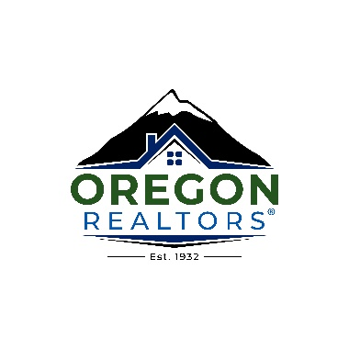MARKETING COMMUNICATIONS MANAGER

Develop and execute member-benefit driven electronic and hard copy communication and marketing messages. Develop and maintain business tools, programs, information resources and events targeted to meet member and staff needs. Perform web site updates. Assist all Oregon REALTORS® departments with electronic communication to ensure communication is in keeping with Oregon REALTORS® brand.

Responsibilities
- Assist with communications projects to ensure consistent, benefit-driven messaging and cross-marketing. Messaging should nurture in the member a sense of value for and connection to Oregon REALTORS®.
- Assist other departments with development of electronic benefit-driven communication messages to strengthen their programs and initiatives.
- Perform web site updates and web site management
- Employ appropriate measurement analytics to assess online communication effectiveness
- Identify and recommend ways to apply existing and emerging technologies to meet member needs and challenges and enhance Columbus REALTORS® communications effectiveness.
- Assist with public relations outreach programs and messages to improve relationship with the media and public to support Oregon REALTORS®’ influence and credibility
- Oversee production of member electronic communications and resource materials as needed
- Perform regular web site updates and web site management

Specific tasks include, but are not limited to:
- Update web site regularly with information valuable to members - news articles, event photos, page updates, etc.
- Write/distribute weekly and monthly eNewsletters to segmented member populations
- Create/send other member emails as needed
- Promote industry information/events as well as the professionalism of REALTORS® through social media
- Photography – take pictures/video at events
- Write articles of interest and edit

KNOWLEDGE, SKILLS AND ABILITIES
- Well organized and ability to meet deadlines
- Excellent communication skills – both written and oral
- Ability to work with a wide range of personalities and computer competency levels
- Ability to execute tasks independently
- Ability to establish and maintain positive working relationships with employees, leadership, service providers, peers in other organizations and, most importantly, members
- Thorough understanding of AP style guidelines

Above average working knowledge of relevant software applications including:
- Microsoft Outlook (advanced)
- Microsoft Word (advanced)
- Microsoft Excel (beginner)
- Adobe Acrobat / Distiller (intermediate)
- Photoshop, Canva, or another editing software (intermediate)
- Basic knowledge of html code (or interest in learning)
- Audio and video editing software (Willing to learn)
- Wordpress
- Constant Contact
- Hootsuite

EDUCATION AND EXPERIENCE
- Communication – related college degree required with strong technical skills
- 3-5 Years experience in marketing
- A thorough background check will be conducted for security purposes

PHYSICAL REQUIREMENTS
- Mostly office work requiring extended periods of time sitting and working on computer
- Some attendance at off-site events and association functions

SALARY RANGE - $48-53k/annually

