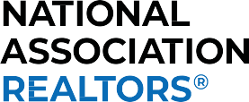

THE NATIONAL ASSOCIATION OF REALTORS®
New Member Code of Ethics Course Certiﬁcate of Completion

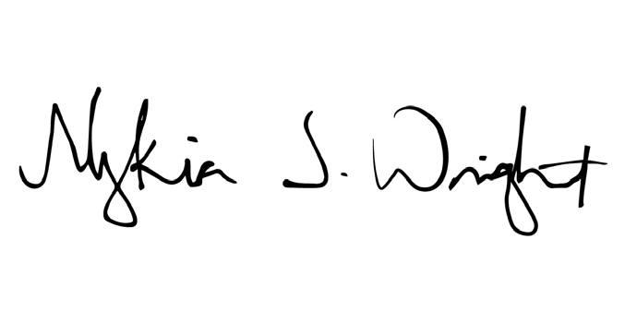
M1 MEMBER ID:
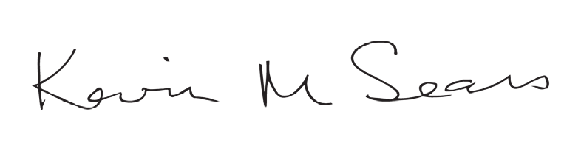
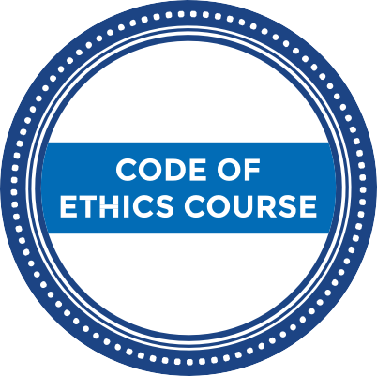

Kevin Sears
2024 President
NEW MEMBER
CERTIFICATE OF COMPLETION

Nykia Wright
NAR Interim CEO

