2019 Leadership Academy Application  This form is for your use offline. To submit your application by the deadline date of March 9, 2018, use the online form at NAR.REALTOR/LeadershipAcademy. | 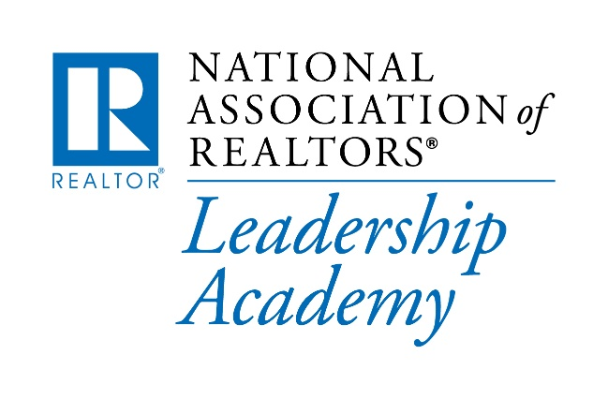

Important: Use this form to gather information that needs to be entered into the
Leadership Academy Application form on NAR.REALTOR ONLY.

Please do not email, fax or mail the form below.

Name: | Your name and address information will be populated from our membership system, based on the NRDS # provided when you start filling out the application. Any address changes need to be made directly to your record in the National REALTOR® Data System (NRDS).
NRDS#:

Address: | E-mail:

Section I - Personal Data

First name or nickname preferred:

Home address:

Cell Phone:

Business Address:

Business Phone:

Preferred method of contact: |  Cell Phone   Business Phone   E-mail
Real estate specialty (check all that apply): |  Residential   Commercial   Resort   Appraisal   International   Buyer Brokerage   Brokerage Management   Land   Trainer/Instructor   Other (provide more information below)
Real estate designations earned.

Number of years in the real estate business.

Have you applied for admission to the Academy before? |  Yes  No

Section II - Education

- Indicate the highest level of education attained: |  GED   High School   Trade School   Bachelor's Degree   Master's Degree   Doctorate Degree   Other
- Provide the following information for advanced degrees:

- Name and location of school
- Degree
- Major
- Date degree earned

- Have you completed other formal leadership training?

- Name of sponsoring organization
- Year of completion
- Course title

Section III - Work Experience

Present firm name

Position

Position start date (year)

Briefly describe your job responsibilities.

List your career / occupation(s) prior to real estate.

Section IV - REALTOR® Association Involvement

Please provide the following information for each of the five questions below:

- Name of association
- Position held or assignment
- Date of affiliation

- List your involvement with your local association of REALTORS®.

- List your involvement with your state association of REALTORS®.

- List your involvement with the NATIONAL ASSOCIATION OF REALTORS®.

- List your involvement with other professional real estate industry associations.

- List special honors and/or awards received.

Section V - Community Involvement

- List community, civic, religious, political, governmental, athletic, social, or other areas of active involvement. Provide:

- Name of organization
- Assignment / position
- Describe responsibilities

- List leadership/special honors and/or awards received.

Section VI - Professional References
In determining the candidates to be qualified for inclusion in the Leadership Academy, we ask that you thoughtfully complete the online application and submit three (3) professional references. The three required professional references should be from the following categories:

- State REALTOR® officer
- State Association Executive
- Local Association Executive
- Local REALTOR® officer

References must be submitted online through the URL that will be provided when filling out the application. Copy and paste that URL and send it by e-mail to each of your professional references. Please note that the system will not accept more than three references.

Your unique URL: (provided online)

Note that the URL outlined above is unique for your application and that all references must use this URL in its entirety. A NAR.REALTOR member login containing a valid NRDS ID is required to access this URL.

You will need to certify that you acknowledge that references received are confidential and will not be shared with you.

You will not be able to submit your application until the three required references have been received or after the due date of March 9, 2018. You are responsible for ensuring that a reference is received from the four categories outlined above. Please check back before the application due date to verify that all three (3) references have been received and to submit your application to NAR. The names of those who have submitted a reference on your behalf are within the application.

Section VII - General Information

Please answer the following in a few short sentences.

- Why did you decide to apply for the Leadership Academy?
- What is your definition of an effective leader?
- What personal leadership skills would you like to improve?
- Specifically, what areas of leadership training would be most beneficial to you and why?
- As you see the world today, what are the most significant challenges of being a leader?

REALTOR® University Leadership Institute Leadership Assessment

As of 2018, all NAR Leadership Academy Applicants should complete the REALTOR® University Leadership Assessment. Applicants are able to take the assessment multiple times and the highest results will be reviewed.

To access the Leadership Assessment and User Guide, please go to the REALTOR® University Leadership Institute Homepage.

☐REALTOR® University Leadership Assessment Completed

Application Agreement

I understand the purpose of the NAR Leadership Academy, and if I am selected, I will devote the time and financial resources necessary to complete the program. Further, I understand that if I miss one session (in-person or online), the Advisory Board will decide on how the assignment will be made up. If I miss two sessions, I will automatically be dropped from the program and reapply when I can commit the time. I also agree to all terms and conditions of this application.

BEFORE YOU CLICK ON THE SUBMIT BUTTON, PLEASE PRINT/SAVE A
COPY OF YOUR APPLICATION FOR YOUR RECORDS.

Application Deadline: March 9, 2018

Questions? Call Judy Perez at 312.329.8548 or e-mail jperez@realtors.org.

