This search is being conducted by

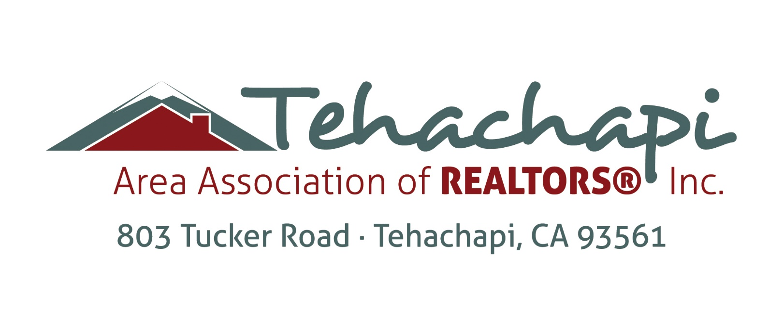
Association Executive
Position Profile

Application Deadline is
April 16, 2018 at 4:00pm

Seeking Full-Time Association Executive
Tehachapi Area Association of REALTORS®, Tehachapi, CA
Compensation: Salary commensurate with experience
Application Deadline: April 16, 2018 at 4:00pm PT
Send Cover Letter, Resume and Salary Requirements to Jim Hutson, 801 W Tehachapi Blvd. Tehachapi, CA 93561 or email accessjim@att.net

The Tehachapi Area Association of REALTORS® (TAAR), with the support of ….
is recruiting and evaluating candidates for the position of Association Executive.
TAAR is eager to identify a dynamic association executive who is prepared to build upon the current successes of the Association. The successful candidate will serve as the Association Executive of TAAR and Tehachapi MLS, overseeing the operations and activities of the Association as a whole, advising and making recommendations to the Officers, Board of Directors and Executive Committee, administering and implementing decisions made by the Board of Directors and maintain effective staff performance to assure the attainment of the association’s goals.
About the Tehachapi Area Association of REALTORS®
The Tehachapi Area Association of REALTORS®, Inc. was established in 1986.
Tehachapi is a quaint community located in the mountains between the San Joaquin Valley and the Mojave Desert, offering a cool haven from the arid desert heat and the sprawling lowlands of the valley. Sparkling blue skies turn into star filled nights, the beauty of Tehachapi is seen in every setting. The diversity of the area offers small town neighborhoods, mountains filled with oak and pine trees sheltering the most rustic to the most luxurious homes, sprawling ranches and everything in between, all during four wonderfully distinct seasons.
TAAR is the leading organization providing information services, research and education on the real estate industry for brokers, real estate professionals and the public. As a petite association we have 125 REALTORS® 30 Affiliate members. Including 135 MLS members there is a total of 290 members.
Mission: The Tehachapi Area Association of REALTORS® advocates, protects and promotes the standards of REALTORS® for the benefit of the communities they serve. Adopted September 18, 2012

Vision: The Tehachapi Area Association of REALTOS® supports and unites its members through uncommon leadership, professionalism and service. Adopted June 27, 2017

Values:
EXCELLENCE: The highest professional and ethical standards will govern our work and our relationships.
DIVERSE/INCLUSIVE: Respect for serving members representing all cultures and business models.
RELEVANCE/INNOVATION: We continually explore new avenues to provide better service/relevance to our members/community.
UNITY: Unity is strength. Building trust through integrity and respect. Working together toward a common vision.
ADVOCACY – We are seen by our members, the public, media and elected officials as the leading advocate for private property rights and real property ownership.
COLLABORATION – A commitment to working with other organizations as a trusted and supportive community partner to benefit our member/stakeholders.
Position Description
Hired by and reports to President and Board of Directors. Decision making authority for all operational procedures is vested in the AE/CEO.
- Lead and oversee the implementation of the Association’s long and short-term plans in accordance with its strategy;
- Ensure the Association is appropriately organized and staffed and to have the authority to hire and terminate staff as necessary to enable it to achieve the approved strategy;
- In conjunction with the Strategic Planning and Finance Committee, the Board of Directors and bookkeeper, develop a budget to support the implementation of the Association’s Strategic Plan.
- Ensure that expenditures of the Association are within the authorized annual budgets
- Assess the principal risks of the Association and to ensure that these risks are being monitored and managed;
- Ensure effective internal controls and management information systems are in place;
- Ensure that the Association has appropriate systems to enable it to conduct its activities both lawfully and ethically;
- Act as a liaison between staff and the Board of Directors;
- Communicate effectively with all members, employees, Government authorities, and the public;
- Keep abreast of all material undertakings and activities of the Association and all material external factors affecting the Association and ensure that processes and systems are in place to ensure that the AE and staff of the Association are adequately informed;
- Ensure that the Board of Directors are properly informed, and that sufficient information is provided to enable their ability to form appropriate judgments;
- Ensure the integrity of all public disclosure by the Association;
- In concert with the President, develop Board of Director agendas;
- Request that special meetings of the Board of Directors be called when appropriate;
- In concert with the President, determine the date, time and location of the annual meeting of Association and develop the agenda for the meeting;
- In conjunction with Association’s Leadership Committee, lead the continued development and implementation of a comprehensive and relevant program to grow our future leaders.
- Sit in on committees of the Association where appropriate
- Abide by specific internally established control systems and authorities, to lead by personal example and encourage all employees to conduct their activities in accordance with all applicable laws and the Association’s standards and policies.

Association Executive Profile
Ideal candidates for this position will be a dedicated leader who embraces change and is highly motivated to create a social, political, economic and cultural landscape that’s conductive to staff and member success. Candidate will bring a variety of experiences and attributes to the association including:
- Excellent communication skills including the ability to articulate the value of TAAR to its members, and the community; communicate directly and clearly with staff and volunteers; and have active listening skills.
- Ability to build and cultivate relationships and work collaboratively with internal and external stakeholders.
- Ability to build (recruit & retain), lead and motivate an effective team of staff, volunteers and leadership
- Understanding of the importance of strategic planning and the ability to execute and implement an annual work plan to achieve the association’s goals and objectives.
- Financial leadership and understanding of sound financial management practices.
- Respectful, honest, transparent, and ethical leadership style
- Respect for and ability to promote diversity on the Board, staff and with members
- Progressive, innovative thoughtful leadership.

Qualifications
The Association Executive is committed to TAAR’s mission, vision, values, and should have proven leadership experience. Concrete demonstrable experience and other qualifications include:
Required:
- Must have strong written and verbal communication skills and be a persuasive and passionate communicator, comfortable speaking in front of professional groups
- Must reside in, or be willing to relocate, to the Tehachapi area
- Must demonstrate the ability to work effectively in collaboration with diverse groups of people
- Minimum 5 years of management experience or equivalent
- Demonstrated ability to plan organization-wide activities (setting objective, developing strategies, budgeting, developing policies and procedures and organizing the functions necessary to accomplish the activities)
- Willingness to travel to state and national meetings as approved by the Board of Directors.
- Must demonstrate idealism, integrity, and a positive attitude and be mission-driven and self-directed
- In depth knowledge of the management process as it relates to growth and long-term planning is required
- Must be able to think strategically and critically, synthesize complex issues and information and manage change
- Understanding of legal and ethical environments of real estate, regulatory and professional standards
Preferred
- Experience maintaining a presence with public and elected officials
- Proven track record of working successfully with a Board of Directors
- A record in growing organizations from a revenue and value perspective
- Financial management in a non-profit organization, including budget preparation and implementation

Application
Send cover letter, resume and salary requirements by 4:00pm PT April 13,2018 to the search team. If these items are not provided in their entirety by the deadline your submission will not be considered. Also, in the cover letter, please provide brief details stating how you meet the qualifications listed and how you can positively contribute to TAAR now and into the future. Thoughtful responses are greatly appreciated by the search team.

