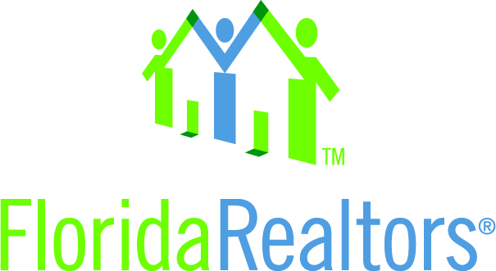

State Leadership Idea Exchange Council – REALTORS® Believe

REALTORS® believe in our communities, that housing matters, and that we can make a difference: raising awareness and helping to combat family homelessness has been a key focus for us this year

The REALTORS® believe tour was an effort undertaken to raise awareness and change the face of homelessness within our membership. Most importantly, it was to recognize and raise awareness of the ongoing efforts of Realtors and those in our communities who are the “boots-on-the-ground” making a difference day in and day out to affect and hopefully end homelessness in our state. The Tour spanned the entire length of the state, from the panhandle all the way to the keys, bringing the leadership team coast to coast and all areas in between. In total, we logged over 3300+ miles. The Leadership met with the 13 Florida Realtor Districts to recognize, applaud and bring awareness to their community efforts. Family homelessness was a key focus, as we realized that this is something that could affect all of us. It’s not them, it’s us. Each conference was attended by anywhere from 50 to 400 REALTORS. Most, if not all, conferences had a local charitable organization or individual present at the conference. Some arranged for our leadership team to take onsite tours of community homeless shelters.
Sadowski and homeless funding among victories
The last time Florida lawmakers directed Sadowski Affordable Housing Trust Funds to housing and not general revenue, Florida upset Ohio State to win the BCS Championship and Apple introduced the iPhone. It's a different story this year. For the first time in seven years, a significant amount of money collected for the Sadowski Funds from a portion of doc stamp taxes will go toward housing. It was one of several victories for Florida Realtors during the 2014 legislative session which ended May 2.
When the state faced a budget shortfall, legislators felt the need to sweep Sadowski monies into general revenue. This year, there was a $1.2 billion budget surplus. It's a huge victory for Florida Realtors, for the property owners who pay doc stamps and, most importantly, for the thousands of Floridians, many of them school-age children, who benefit from housing funds.
Of the $167 million appropriated to the Sadowski Funds, lawmakers directed $100 million to the State Housing Initiative Program (SHIP) and $67.7 million to State Apartment Incentive Loans (SAIL). SHIP provides money to refurbish existing homes for low-income families and provides down payment assistance and lease-purchase assistance. SAIL provides rental assistance.
Help for the homeless. Florida Realtors 2014 President Sherri Meadows made homelessness a priority this year, and the association advocated for legislation that provides housing for extremely low-income and homeless populations by funding local homeless coalitions. HB 979 by Rep. Kathleen Peters (R-St. Petersburg) establishes challenge grants for local homeless coalitions, nonprofits and other agencies that assist the homeless, and will also provide these agencies with training and technical assistance. The Senate companion bill, SB 1090 by Sen. Jack Latvala (R-Clearwater), included a dedicated revenue source for homeless programs through the Department of Children and Families. While this provision didn't make it into the final legislation, the 2014-2015 state budget provides $4 million for homeless programs. Effective July 1, 2014.

Housing Matters Summit on Family Homelessness
Advocates Say: Housing Must Come First, REALTORS® are uniquely positioned to help find answers.

Our 2014 Leadership team were among the more than 250 community activists, business leaders, Realtors, and local, state and national advocates for the homeless who spoke at the Florida Realtors-sponsored “Housing Matters Summit on Family Homelessness” on Sept. 22 in Orlando. The message was clear, Florida Realtors is a dedicated advocate for housing at all income levels. When families have a secure and stable lifetime residence, they can build a foundation for self-sufficiency. Getting people into housing is the crucial first step, advocates agreed, noting Florida desperately needs more low-income workforce housing units.

In fact, 58.7 percent of Florida’s homeless population had homes a year ago. “Having a home is a baseline need for everyone,” said Erik Braun, executive director of the Florida Department of Children and Families’ (DCF) Office of Homelessness. “Family homelessness impacts families for generations. The way we deal with it now is going to have an impact on family homelessness in the future.” He urged Realtors to continue to be a part of the efforts to end homelessness, adding “business leaders and entrepreneurs can speak to the bottom line. They have leverage that perhaps the agencies and nonprofits don’t have.”

Did you know? Summit highlights
• Family homelessness is about economics; chronic homelessness is about disabilities
• Every school district in the U.S. has a homelessness liaison
• Causal issues related to homelessness: lack of childcare, joblessness and underemployment, lack of transportation, lack of affordable housing and rental housing obstacles such as bad credit, past evictions or lack of references

