2013 RSPS Award Winners
RSPS of the Year:
Aleta Azarian, ABRM, CRB, RSPS, SFR®, SRES(r)
Aleta Azarian has been a Realtor for almost 40 years. She opened her first office in the resort town of Harwich Port and grew her business to include multiple offices on Cape Cod, and developed a large resort rental business along the Cape Cod National Seashore. After 25 years, Aleta sold her business to a national firm, and became the Branch Manager of 3 highly successful resort sales and rental offices. Supporting and encouraging community involvement has been a constant throughout Aleta’s career. Giving back to our communities adds to the vibrancy of an already beautiful part of the world, and rewards us with an abundance of both seasonal visitors and new home buyers.

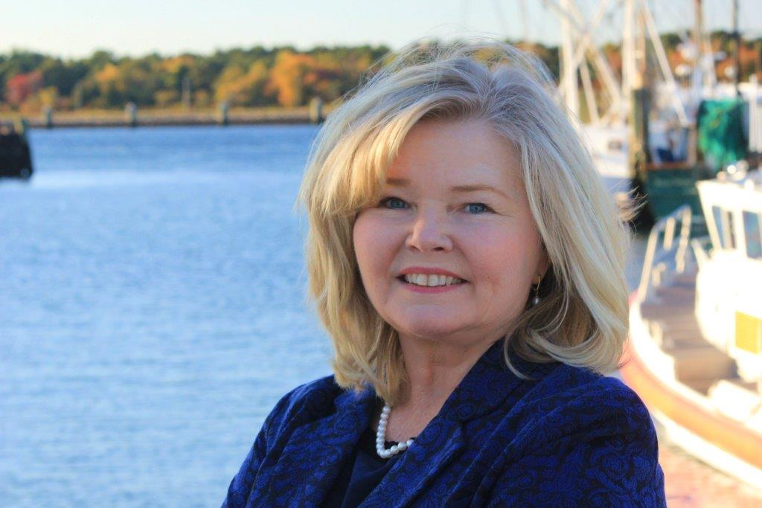

RSPS Rising Star:
Fabiola Kinder, CIPS, RSPS
Fabiola Kinder, a native of Haiti, has made the U.S. her home since 1980. Previously in the hotel management business, she has practiced resort residential and commercial real estate in the communities of Laguna Beach, Newport Beach, and Baja since 1999. Fabiola is Laguna Beach Sister Cities Association’s liaison with San José del Cabo, in Mexico. As the Nextdoor.com Bluebird-Montage neighborhood leader, Fabiola promotes neighborliness and disaster preparedness in an area of many second homes. She has volunteered in arts organizations and on a subcommittee to help keep housing affordable for Laguna Beach artists. With a population
of about 23,000, Laguna Beach has 20,000 acres of wilderness, 20+ coves, and world-class tidepools. It is a magnet for over 400 resident artists and over six million domestic and international guests annually. Trip Advisor Reader’s Choice Awards for 2013 named Laguna Beach in the Top Ten Beach Cities in the United States.

