Missouri REALTORS®: New Logo - New Look
When the Missouri Association of REALTORS® adopted its new Strategic Plan, a core strategic objective was to ENGAGE members with compelling programs, services, products and events that demonstrate and validate member value. Inherent in this effort to engage is an effective marketing strategy that focuses on building brand equity with its members.

To this end, the Association began an effort in mid-2012 to re-brand itself. A Branding PAG was created. It determined that the existing logo was a bit dated and the tag line was not unique to Missouri.

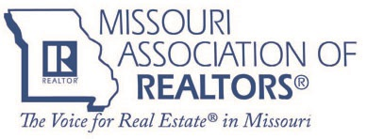

The Branding PAG worked with staff to develop a new logo, tag line and brand promise. These new branding elements were put in front of our Board of Directors in September, 2012 and the Board determined that the ideas presented did not quite fit our Association. Undeterred, the Branding PAG went back to the drawing board. It solicited members for more input and came back to the Board of Directors in January, 2013 with a new concept. Success! The Board voted nearly unanimously to adopt a new logo, tag line and brand promise, along with changing the trade name of the Association to Missouri REALTORS®.
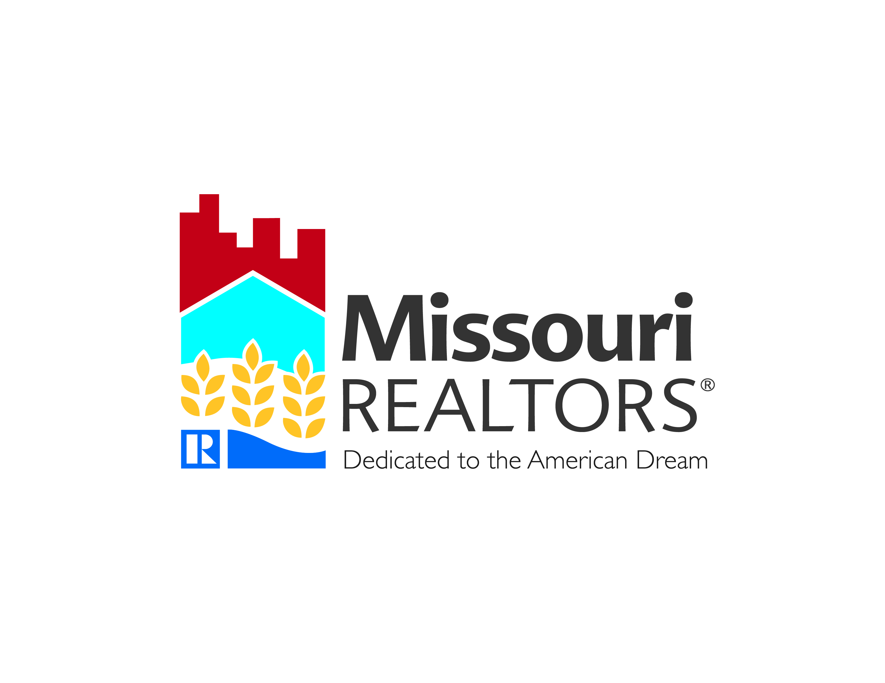

The new logo depicts the three sectors of REALTOR business in Missouri, commercial in red, residential in blue and land in yellow. These elements are underscored by the Missouri river and the REALTOR “R”. The tag line, “Dedicated to the American Dream”, is something that Missouri REALTORS feel very strongly about. The American Dream is a core belief of the Midwest culture and the nation’s heartland.

To go along with the new logo and tag line is a Brand Promise that characterizes two levels of the brand, the Association to its members and its members to consumers.

Missouri REALTORS® are among the very best in the country. Thousands of hardworking real estate professionals and recognized industry leaders are proud to call Missouri “home”. Uncompromising Midwest values, an honest work ethic, and a genuine commitment to the communities in which they live and serve, characterize this dedicated group who are agents of the American Dream. As an organization, the Association endeavors to provide unparalleled, world-class service. Missouri REALTORS® strive to meet and exceed expectations while also building a strong sense of community among its members

To launch the new brand, the Association produced a video that was first shown at our recent Business Conference in Kansas City. The video is intended to create an emotional tie between members, what they do, and the new logo, tag line and Association trade name. The feedback from members has been universally positive, enthusiastic and supportive. The video is available online and has more than 1000 views in just one month. It has been widely shared on social networks and elicited many ‘thumbs up’ reviews.

MISSOURI REALTORS NEW BRAND VIDEO
http://www.youtube.com/watch?v=hK5mBvhAnRI

We are now conducting focus groups to begin the next phase of our new brand rollout. We are encouraged with how excited members are to learn more about the Association’s fresh new look and more importantly, what it means to them in the context of more value.

