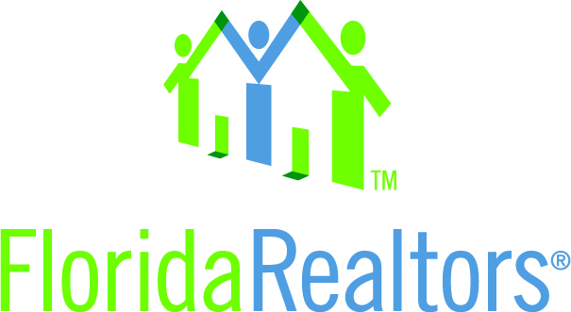

State Leadership Idea Exchange Council – digital “Talking Contract”

It's like having your own attorney talking you through a contract - Florida Realtors released new versions of 3 of its most popular contracts, including the residential contract for sale & purchase. In the past, Florida Realtors attorneys would instruct members on changes to contracts at local boards, at Florida Realtors conferences or via webinar. To reach potentially all members, the Communications Department's Web Team utilized several technologies for a unique online learning experience. PDFs of the contracts were covered to digital flip book format. Professional voice talent recorded commentary about the new forms supplied by Florida Realtors attorneys. The audio was imbedded into the flip book.

And here's the result: http://browndigital.bpc.com/publication/?i=172701

A digital "Talking Contract" that's available on the association's member website, floridarealtors.org. Members simply click on a page of the digital flipbook and listen as the forms changes are explained.

State Leadership Idea Exchange Council – Florida Realtors Membership Study

"In today’s challenging economy where every market has differing characteristics, it is vitally important for REALTOR® Associations to have clear, accurate information to present to its members for guidance.” –
Every three years, via our Strategic Planning Committee, Florida Realtors engages a prestigious research firm to provide a detailed, yet comprehensive member assessment. This survey is conducted by phone interviews in early summer and is scientifically, statistically valid within a 95 percent confidence level. The results are very encouraging.

Here are a few top-tier takeaways:
- REALTORS® today contend not only with a complex sales process, they also have to adapt to the way they market their businesses as well. The rise of the internet and social media, as well as the changing demands of younger, first-time homebuyers make it vital for real estate professionals to have up-to-date data and training that is meaningful to their business.
- Members rate Florida Realtors 8.5 on a 10 scale with 10 being the highest; an increase from 7.7 in 2007;

- Members rate Florida Realtors an 8.5 on a 10 scale with 10 being the highest when asked to compare," what you get for what you pay." Two-thirds of members think they are paying more than they are in state dues;

- 84 percent of members believe Florida Realtors helps them in their real estate business;

- Members, if given the choice, would be very likely or likely to join their local and state association. This belief has increased since 2007;

- Asked to name benefits—without any prompting— the average member could name about seven Florida Realtors benefits…that's double from 2007;

- Members have an "exceptionally high awareness" of our government and legislative activities;

- On the “1 to 10” scale with 10 being the highest, these services rated an 8 or higher: Florida Realtor® Magazine, The Legal Hotline, Research and Market Statistics, Legislative and Political Action and Florida Realtors® News. Our member web site, floridarealtors.org, pulled a 7.9 and four other services rated a 7.4 or higher, including the Tech Helpline.

