FOR IMMEDIATE RELEASE:
Contact:
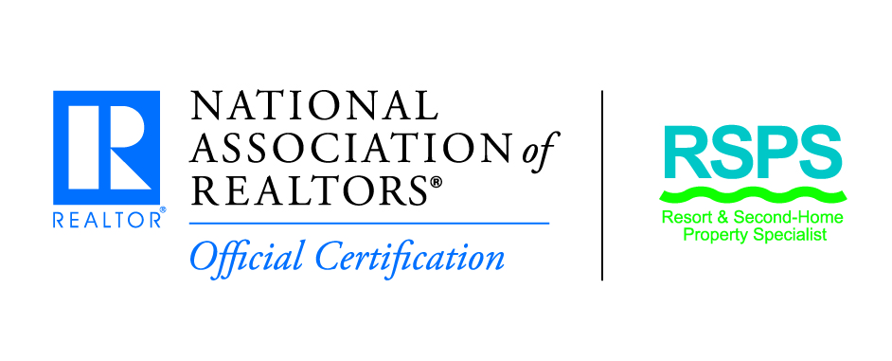
Contact Person:
Company Name:
Telephone Number:
Fax Number:
Email Address:
Website address:

____________________________________________________________________________________

(Date)
(Your Town) – (Your Name) with ([insert the name of your association or brokerage] has been awarded the Resort and Second-Home Property Specialist (RSPS) certification. The RSPS certification is a nationally-recognized certification awarded by the National Association of REALTORS® to real estate professionals who wish to demonstrate and promote – to consumers and their peers alike – their expertise in the resort and second-home specialty.
(Your name) joins more than 4,000 real estate professionals who have earned the RSPS certification. REALTORS® who receive the RSPS certification have successfully completed the Resort & Second-Home Specialist (RSPS) Certification Course. (He/She) now joins other real estate professionals who specialize in buying, selling, or managing second-homes in a resort, recreational, and/or vacation destination and properties for investment, development, or retirement.
[Optional: insert short bio here with relevant experience related to working with second-home properties]
REALTORS® or consumers interested in learning more about the program can visit www.nar.realtor/resort or contact RSPS Member Services at 800/874-6500, Ext. 8320.

