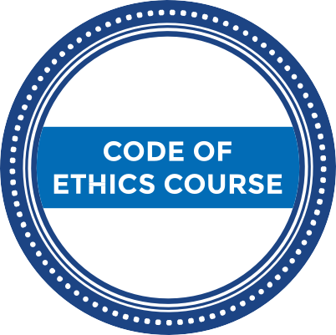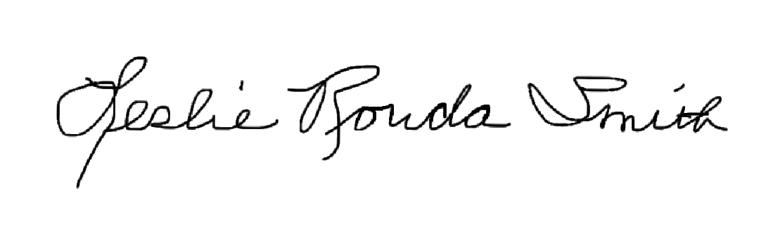
NEW MEMBER
Leslie Rouda Smith
2022 President
CERTIFICATE OF COMPLETION

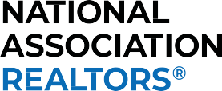

THE NATIONAL ASSOCIATION OF REALTORS®
New Member Code of Ethics Course Certiﬁcate of Completion

M1 MEMBER ID:

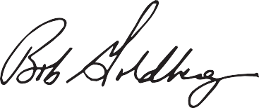

Bob Goldberg
NAR CEO

