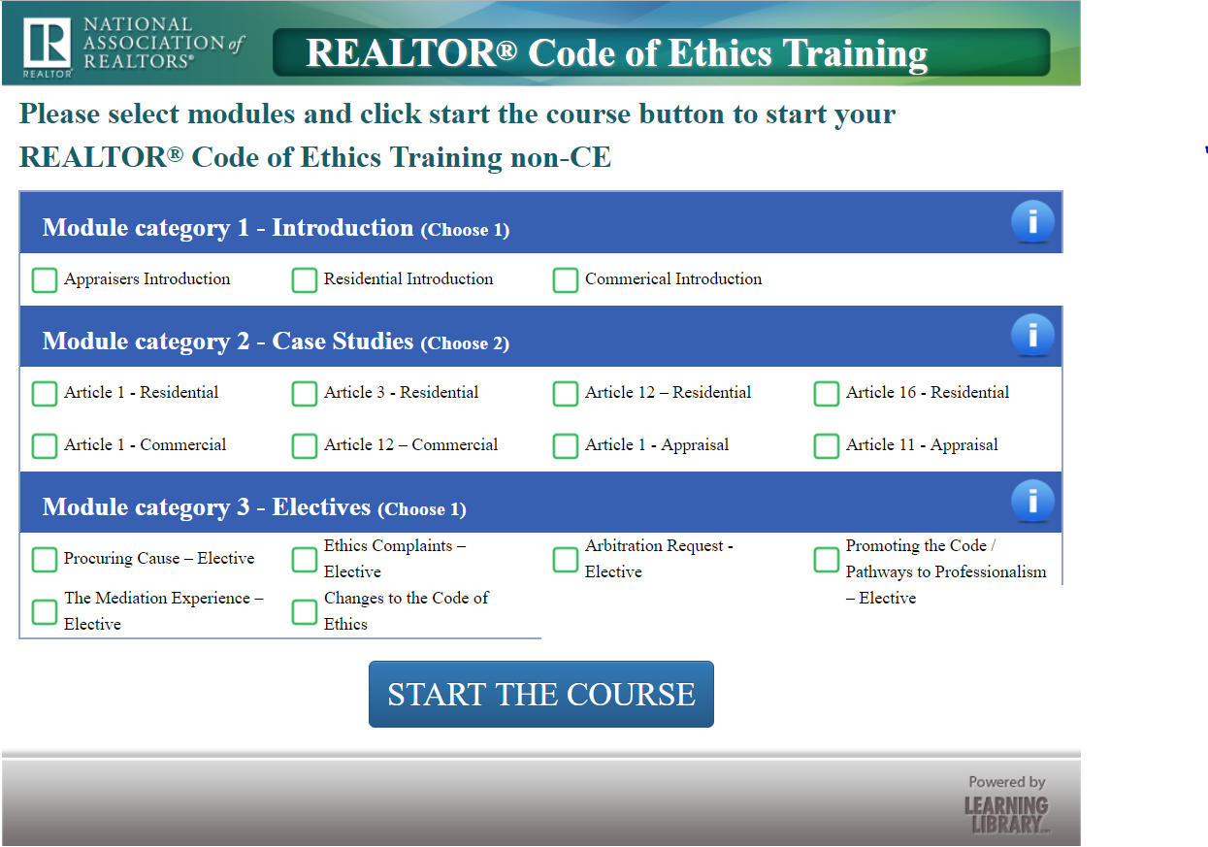

Once a student selects the free non-CE Code of Ethics training course they must:

Select one (1) Introduction. A brief description of the introduction options follow:
Appraisal Introduction
In this module, REALTORS® who specialize in appraisal will learn how the REALTOR® Code of Ethics applies to them. Students will examine specifically developed appraisal content about: the aspirational concepts in the Preamble of the Code of Ethics, the concept of general business ethics and how it compares and contrasts with the duties established in the REALTOR® Code of Ethics and how professional standards are enforced by the local associations of REALTORS®.
Residential Introduction
In this module, REALTORS® who specialize in residential real estate will learn how the REALTOR® Code of Ethics applies to them. Students will examine: the aspirational concepts in the Preamble of the Code of Ethics, the concept of general business ethics and how it compares and contrasts with the duties established in the REALTOR® Code of Ethics and how professional standards are enforced by local associations of REALTORS®.
Commercial Introduction
In this module, REALTORS® who specialize in commercial real estate will learn how the REALTOR® Code of Ethics applies to them. Students will examine specifically developed commercial content about: the aspirational concepts in the Preamble of the Code of Ethics, the concept of general business ethics and how it compares and contrasts with the duties in the REALTORS® Code of Ethics and how professional standards are enforced by associations of REALTORS®.

Select two (2) Case Studies. A brief description of the case study options follow:
Article 1 - Residential
This module explains the important concepts of Article 1 of the Code of Ethics. Students will review case studies and scenarios, examine Article 1’s Standards of Practice and learn to identify possible violations of the Article.
Article 3 - Residential
This module explains the important concepts of Article 3 of the Code of Ethics. Students will review case studies and scenarios, examine Article 3’s Standards of Practice and learn to identify possible violations of the Article.
Article 12 – Residential
This module explains the important concepts of Article 12 of the Code of Ethics. Students will review case studies and scenarios, examine Article 12’s Standards of Practice and learn to identify possible violations of the Article.
Article 16 - Residential
This module explains the important concepts of Article 16 of the Code of Ethics. Students will review case studies and scenarios, examine Article 16’s Standards of Practice and learn to identify possible violations of the Article.
Article 1 - Commercial
This module explains the important concepts of Article 1 of the Code of Ethics in commercial real estate. Students will review case studies and scenarios, examine Article 1’s Standards of Practice and learn to identify possible violations of the Article.
Article 12 – Commercial
This module explains the important concepts of Article 12 of the Code of Ethics in commercial real estate. Students will review case studies and scenarios, examine Article 12’s Standards of Practice and learn to identify possible violations of the Article.
Article 1 - Appraisal
This module explains the important concepts of Article 1 of the Code of Ethics in appraisal. Students will review case studies and scenarios, examine Article 1’s Standards of Practice and learn to identify possible violations of the Article.
Article 11 - Appraisal
This module explores the important concepts of Article 11 of the Code of Ethics in appraisal. Students will review case studies and scenarios, examine Article 11’s Standards of Practice and learn to identify possible violations of the Article.

Select one (1) Elective. A brief description of the elective options follow:
Procuring Cause
This module explains the often misunderstood concept of procuring cause and how it is used in making offers of compensation and in deciding arbitration claims over disputed commissions.
Ethics Complaints
This module brings to life the process for filing and participating in a hearing of an ethics complaint.
Arbitration Request
This module brings to life the process for filing and participating in a hearing of an arbitration request.
Pathways to Professionalism / Marketing the Code of Ethics
This module explains "Pathways to Professionalism", a list of professional courtesies and discusses how it can enhance relations between REALTORS® and how it ensures professional services to clients and consumers. This module also discusses how to market and use the REALTOR® Code of Ethics in your everyday business.
The Mediation Experience
This module brings to life NAR’s preferred dispute resolution system, mediation.
Changes to the Code of Ethics
This module explains recent changes to the Code of Ethics and the Professional Standards enforcement process.

